2022-06-06 version - Typos and expression errors corrected and visible with Word’s Track Changes
(To see these with Word 365, I have to use View > Draft and then (to see images again) View > Print.)

Please see the last page for a handful of potentially significant typos in the version sent by deadline, which are corrected here.

The UK Government's Open consultation: Vitamin D: call for evidence
Below is my submission to the Office for Health Improvement & Disparities call for evidence (2022-04-03):
https://www.gov.uk/government/consultations/vitamin-d-call-for-evidence/vitamin-d-call-for-evidence
This submission was written by Robin Whittle.
Patrick Chambers MD, of the USA, has reviewed this and requested to be a co-signer. He has written his own submission including a note to this effect.
Patrick gained his Bachelor of Arts at Princeton University in 1971, specializing in Mathematics. He studied Medicine at University of California, Davis and after graduating in 1975 studied at the LA County/USC Medical Center, gaining a degree in Anatomic and Clinical Pathology (board certified) in 1979. From 1979 he worked in the Department of Pathology, Torrance Memorial Medical Center, in California, mainly as Managing Director. He retired and moved to Hawaii in 2004. His research interests https://www.researchgate.net/profile/Patrick-Chambers-4/ include vitamin D, magnesium and other nutrients.
15 May 2022 (First established 2022-05-15.)
Robin Whittle rw@firstpr.com.au Daylesford, Victoria, Australia. I am a UK citizen.
Twitter: https://twitter.com/RobinWhittle3 Substack: https://nutritionmatters.substack.com

My PDF submission is derived from the web page:
https://vitamindstopscovid.info/00-evi/
Contents
Link | Description
#01-intro | Introduction.
#02-compounds | The three vitamin D compounds, and the history of units for these and for 25-hydroxyvitamin D levels.
#03-uk-low | Terribly low 25-hydroxyvitamin D levels in the UK.
#04-health | The need for 125 nmol/L 50 ng/mL 25-hydroxyvitamin D.
#05-history | The UK government's current vitamin D recommendations are based on the erroneous 2011 US/Canadian Institute of Medicine report.
#06-ratios | Vitamin D3 supplemental intake quantities as a ratio of bodyweight.
#07-fortif | Food fortification cannot lead to proper 25-hydroxyvitamin D levels.  I ran out of time to complete this. Fortification cannot provide more than a tiny fraction of the vitamin D3 people need. It would be dishonest to promote it, since it would provide a false assurance.  Please also see the limited options for vitamin D food fortification in the 2006 reference document on fortification from the W.H.O.: https://www.who.int/publications/i/item/9241594012
Frontispiece:
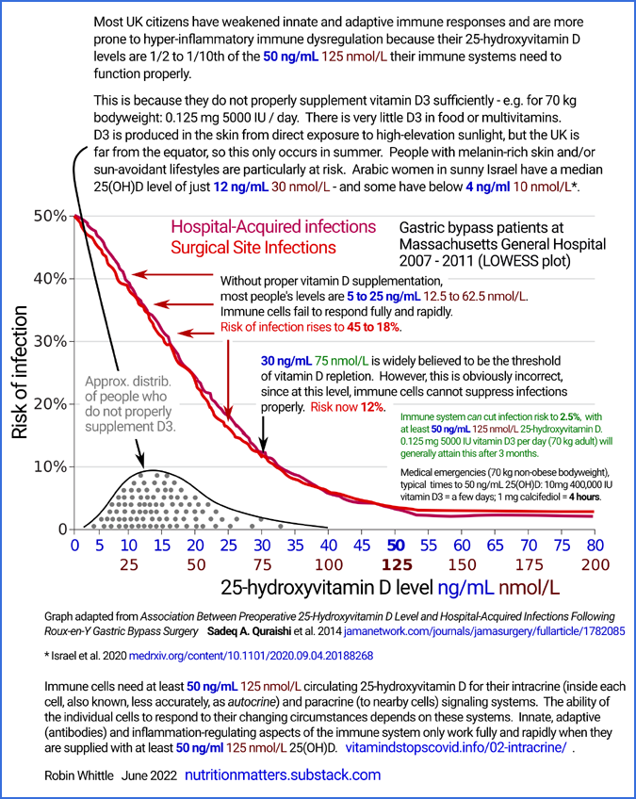
(2022-06-05 update notes: The diagram now states the risk of infection for 62.5 nmol/L 25-hydtoxyvitamin D is "18%”. The initial version stated this was “25%”. Towards the right of the graph the erroneous “0.125ng” has been corrected to “0.125 mg” and the sentences changed to indicate that these are general/typical outcomes.

Association Between Preoperative 25-Hydroxyvitamin D Level and Hospital-Acquired Infections Following Roux-en-Y Gastric Bypass Surgery
Sadeq A. Quraishi et al.
JAMA Surg. 2014-02 https://jamanetwork.com/journals/jamasurgery/fullarticle/1782085

These two similar graphs depicting low pre-operative 25-hydroxyvitamin D levels driving immune system failure, which leads to greatly elevated risk of post-operative infections, are from arguably the most important and easy-to-understand research study on the importance of good 25-hydroxyvitamin D levels for the immune system.
This is from a Boston hospital, showing the risk of primarily bacterial infections rises precipitously from about 2.5% (for both hospital-acquired and wound-site infections) according to how much below 125 nmol/L (50 ng/mL) their pre-operative level of 25-hydroxyvitamin D was.
The risk of each type of infection multiplies a factor of 5 to about 25% when levels are 50 nmol/L (20 ng/mL). This is the official threshold of vitamin D sufficiency in the UK.
Many UK adults and children have still lower levels, such as 12.5 to 25 nmol/L (5 to 10 ng/mL), and so, for all their lives, are at great risk of suffering and harm, due to their immune systems being unable to function anywhere near as well as they would with proper vitamin D3 supplementation.
The patients in this study were all morbidly obese and underwent the same Roux-en-Y gastric bypass operation, which is a complex surgery intended to help with weight loss. There is no reason to believe that people suffering from obesity require higher 25-hydroxyvitamin D levels for proper immune system function than do those who are not suffering from obesity.

#01-intro

1 - Introduction

1.1 Key points
This Call for evidence is most welcome. One of the world’s leading vitamin D researchers, Professor Martin Hewison (University of Birmingham), stated that “England is centre of vitamin D deficiency” and that rickets is still found in some communities in pediatric clinics all over the UK.. This is in a March 2021 interview https://youtu.be/QjbZFupJsMY?t=457 in which one of his slides was:
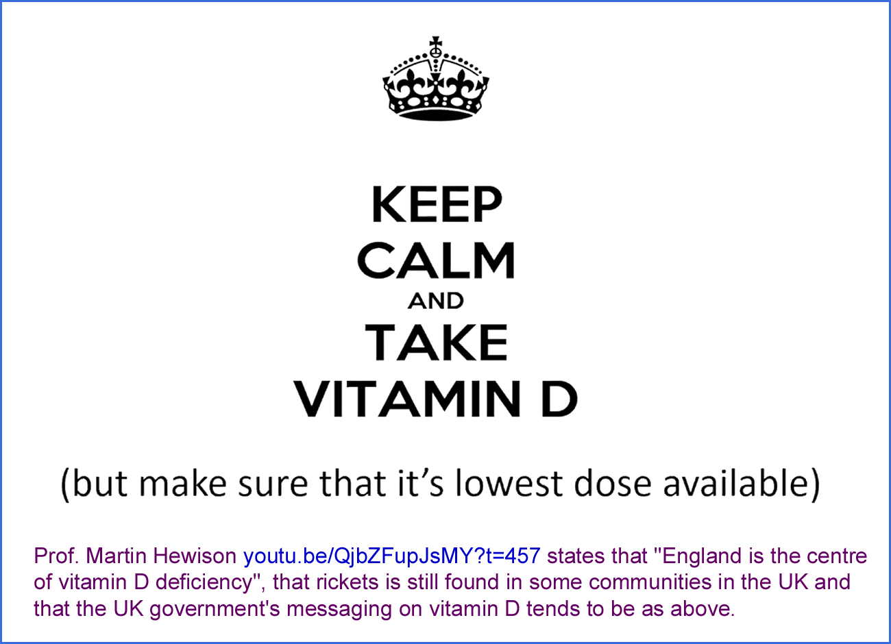
Scotland has even lower average levels of circulating 25-hydroxyvitamin D and all over the country, those with dark skin, sun avoidant lifestyles, the elderly and those suffering from obesity are even more likely to have disastrously low vitamin D levels.
The research articles cited below show beyond doubt that:
- 125 nmol/L (50 ng/mL) circulating 25-hydroxyvitamin D (AKA 25(OH)D) is the proper standard of vitamin D repletion, because levels below this cause weakened innate and adaptive immune responses and raise the risks of self-destructive, hyper-inflammatory (cell destroying) immune responses.
- The current standard of vitamin D sufficiency in the UK - 50 nmol/L (20 ng/mL) 25(OH)D is 60% too low.
The UK’s 25(OH)D standard of repletion is based on 2011 decisions by the North American Institute of Medicine (IOM) which were challenged at the time by knowledgeable researchers, regarding the needs of the immune system. The IOM’s deliberations were based solely on the needs of the kidney to regulate calcium-phosphate-bone metabolism.
The IOM’s statistical method for determining the RDA (Recommended Daily Allowance) of vitamin D3 was shown, several years later, to be entirely mistaken. In order to determine the amount required to attain at least a 50 nmol/L (20 ng/mL) 25(OH)D level in 97.5% of the adult population, they used the variance of the averages of several trials, when they should have used the variance of all the individuals in those trials. They calculated an RDA of 0.015 mg 600 IU.
Subsequent calculations using the studies chosen by the IOM showed the real RDA for this 25(OH)D level is about 0.175 mg 7000 IU. However, the IOM report has never been amended, and remains to this day the foundation of the guidance most or all governments provide for their citizens.
Due in part to the great variation in bodyweight between adults, an RDA is impractical for vitamin D. The only reliable way of attaining good 25(OH)D levels for all people from birth to old age, with all their variation in bodyweight and obesity, is to specify vitamin D supplemental intake quantity as a ratio, or range of ratios of bodyweight, with higher ratios for those suffering from obesity. Vitamin D can be taken weekly or every 10 days. There is no need to take it every day, since the half-life of 25(OH)D is a month or so.
- In general, a person who is not suffering from obesity, with a bodyweight of 70 kg, requires 0.125 mg (5000 IU) to 0.175 mg (7000 IU) vitamin D3 a day to maintain 125 nmol/L or more circulating 25-hydroxyvitamin D.
The current UK recommendation for adults of 0.01mg (400 IU) supplemental vitamin D3 per day is less than a tenth of what a 70 kg non-obese person needs to maintain proper immune system function.
- The health benefits of proper supplementation, for all people other than infants being substantially breast fed by vitamin D replete mothers, are profound and far-reaching.
- Since there is little vitamin D3 in food (fortified or not) and in multivitamins - and since UV-B skin exposure is not always available and always damages DNA and so raises the risk of skin cancer - daily to weekly (or three times a month) supplementation is the only way most people can attain proper vitamin D levels all year round.
Fortunately, the quantities required are small. 5000 IU/day is a gram every 22 years, and ex-factory, pharmaceutical-grade vitamin D3 costs ca. £2 a gram in 1 kg lots.
These supplementation levels are well researched and far below the intakes which might lead to toxicity.
- Food fortification with vitamin D has numerous problems. No practical consumption levels of fortified food can provide more than a small fraction of the vitamin D each person needs to attain 125 nmol/L 25-hydroxyvitamin D sufficiency. So it would be dishonest to support or promote this as government policy.
All efforts and resources which might be considered to introduce or expand vitamin D food fortification would be better dedicated to education and support for proper daily to weekly (or the 10th, 20th and 30th day of each month) vitamin D3 supplementation.

1.2 This website’s name
The name of this site https://vitamindstopscovid.info was chosen in late 2020 based on two principles. While high 25-hydroxyvitamin D levels may somewhat reduce the chance of contracting COVID-19, for any given viral insult, good (125 nmol/L 50 ng/mL or more) levels stop (at least with the variant of mid-2020 in the UK) pandemic transmission by greatly reducing the severity of illness and so reducing the average rate of viral shedding to below that required for pandemic transmission, even in the absence of lockdowns or COVID-19 vaccines. Evidence for this is presented below #04-health.
While this is not provably the case with current variants, the transmission and severity of all COVID-19 variants can best be reduced by ensuring that as many people as possible have at least 125 nmol/L 50 ng/mL 25-hydroxyvitamin D levels AND that they are provided with multiple early treatments, the most effective of which are much safer, more effective and less expensive than the patented, highly profitable, treatments (vaccines included) which are promoted by multinational pharmaceutical companies.
There are numerous observational studies showing COVID-19 severity correlating with low 25-hydroxyvitamin D levels. These low levels are common in the UK, and almost ubiquitous in people with dark skin and/or sun avoidant lifestyles who do not properly supplement vitamin D.
The disastrous suffering, harm, death and social and economic disruption of the COVID-19 pandemic could have been rapidly halted in 2020 if all governments had worked assiduously to ensure their populations had sufficient vitamin D3 for their immune systems to work properly.
Yet the real harm, death, cost and disruption of sub-125 nmol/L 25 hydroxyvitamin D levels is much greater than that caused by COVID-19. It includes sepsis, dozens of inflammatory autoimmune disorders, cancer, Kawasaki disease, MIS-C and acute complications, pre-term birth and lasting developmental disorders of pregnancy. Sepsis alone kills 10 million people a year, worldwide.

1.3 Author's background
Although I have lived in Australia since 1961, I am a British citizen by virtue of being born in Wantage (1955). I work with computer programming and electronic musical instruments. Like many other technically-minded people with no medical training, I became involved in raising awareness of vitamin D's importance to the immune system some years ago, once I realised that this gross and easily-correctable deficiency afflicts the great majority of the world's population.
In July 2020 I established the Nutrition for Immune System Health (NISH) email discussion list: https://nish.groups.io . Members include some of the world's leading vitamin D researchers. I collaborate with some of these in raising awareness of the importance of vitamin D, such as with this submission.
I have no qualifications or expertise regarding medicine or nutrition. Please do not take my word for anything. My purpose in writing is to prompt a full awareness of the most pertinent research articles. Please read these articles!

1.4 Most doctors do not understand vitamin D's importance to the immune system
The question of why many or most doctors, immunologists, virologists, epidemiologists and public health officials are not properly aware of vitamin D's importance to the immune system is a vast and perplexing topic, beyond the scope of this submission. However, some key points should be recognised:
- These people are very busy dealing with myriad complexities and threats to health.
- Doctors in particular are overloaded with information and responsibilities - and much of this information arises from pharmaceutical companies trying to convince the doctor to prescribe their most expensive, profitable, products. This includes a pernicious influence of these companies on the revenues and policies of academic journals, and on the selection and views expressed by the members of government advisory committees.
- The vitamin D research literature is sprawling and it is very difficult to locate the most pertinent research.
- No journal article properly explains - to those who do not already understand it - how 25-hydroxyvitamin D is used by multiple types of immune cells for their intracrine (AKA, less correctly, autocrine) internal signaling systems and their related paracrine signaling to nearby cells. This is unrelated to the hormonal model of vitamin D metabolism with the kidneys regulating calcium-phosphate-bone metabolism.
The immune system is second only in complexity to the nervous system. Coordination between its individual cells of multiple types relies on numerous signaling molecules, such as cytokines [WP <<< Wikipedia link for general background information], and also to some extent on vitamin D based paracrine signaling.
The ability of individual immune cells to respond to their changing circumstances is highly dependent on vitamin D based intracrine signaling. The details differ from one cell type to the next, but the common principle is that this signaling system enables a cell to respond to a particular condition by rapidly changing its gene expression and so the behaviour of the whole cell. This powerful, intracellular, signaling capability is the way most cell types use 25-hydroxyvitamin D. The kidney-based hormonal use of 25-hydroxyvitamin D, which it converts into a very low level of circulating 1,25-dihydroxyvitamin D for hormonally regulating calcium-phosphate-bone metabolism is very well known, but is only one of dozens of functions of the vitamin D compounds.
A proper understanding of vitamin D based intracrine and paracrine signaling is far beyond the knowledge of most doctors, immunologists, etc. - and even beyond the knowledge of many people who research vitamin D. My attempt at a tutorial on these signaling systems is: https://vitamindstopscovid.info/02-intracrine/ . I wrote this because I found no journal article which introduces the mechanisms in a tutorial fashion.
An understanding of these signaling systems is absolutely essential to a proper understanding of the importance of good, 125 nmol/L or more 25-hydroxyvitamin D levels for human health. As such, every doctor, immunologist, virologist, vaccinologist, epidemiologist and public health official is flying blind if they do not understand the vitamin D based intracrine and paracrine signaling systems and have at least a general grasp of how important they are. Without proper supplementation, most people today, usually have 1/2 to 1/10 of the circulating 25-hydroxyvitamin D their immune cells need to function properly.
- Medical doctors are generally poorly trained in nutrition, find it difficult to convince some of their patients of the importance of nutrition and have been regaled with promotion of various nutrients over the years. Many regard claims such as those made for vitamin D as being too simple - too good to be true.
They should read the most pertinent research, as presented here.
A growing proportion of the population is aware of the need for much improved vitamin D supplemental intakes to enable the immune system to work properly. Still, many doctors - while able to do extraordinary work in many difficult, complex, situations - are insufficiently aware of the nutritional deficits and imbalances which worsen or cause numerous chronic and acute diseases, the most prominent of which is vitamin D3.
- A patented compound even a fraction as effective as vitamin D3 would be enormously profitable and so very strongly promoted. Vitamin D3 cannot be patented. There is very little money to be made from it. None of the major pharmaceutical companies make or resell vitamin D3 cholecalciferol. So for-profit pharmaceutical companies benefit from promoting their expensive, complex, supposedly sophisticated products - the need for which would be greatly reduced if most people had sufficient 25-hydroxyvitamin D for their immune systems to work properly.
See long-time vitamin D researcher Bill Grant, PhD's 2018 account of the hostile, unprincipled, actions of some multinational pharmaceutical companies regarding vitamin D: Vitamin D acceptance delayed by Big Pharma following the Disinformation Playbook http://orthomolecular.org/resources/omns/v14n22.shtml.
- The core principles of vitamin D and the immune system are not particularly complex. They are different from the hormonal model all doctors are fully familiar with, which applies only to the role of the kidneys. There has been a greatly regrettable tendency to think of vitamin D (collectively vitamin D3 cholecalciferol, 25-hydroxyvitamin D calcifediol and 1,25-dihydroxyvitamin D calcitriol) as "hormones". This has led to unrealistic concerns about toxicity resulting from supplementation. Calcitriol is the only one of these compounds which acts as a hormone - when it is produced by the kidneys, and circulates at a very low level in the bloodstream for signaling to multiple cell types all over the body, to regulate calcium-phosphate-bone metabolism.
Immune cells' production of calcitriol is unrelated to hormonal (endocrine) signaling. In and between these cells, it acts as an intracrine agent or a paracrine agent, at a much higher concentration than the kidneys’ hormonal calcitriol. This intracellular production of calcitriol does not affect calcium-phosphate-bone metabolism.
- Many concerns about vitamin D toxicity are not founded on the best research.
There is a strong self-limiting mechanism for 25(OH)D which means that the range of vitamin D3 intakes which provide a healthy range of 25(OH)D levels is very wide. This is not the case for vitamin A, iron and many other nutrients.
With bodyweight ratio based supplemental vitamin D3 intake quantities, it is both practical and desirable for all people to maintain good 25(OH)D levels without the need for testing or medical involvement.

1.5 Action based on evidence, rather than on the mistaken views of many doctors, immunologists, etc.
The Secretary of State for Health and Social Care has asked the newly established OHID to solicit evidence from the public regarding improvements to the vitamin D status of people in England.
There's only so much which can be done within the current misguided and ill-informed existing recommendations. All the research mentioned below indicates that the vitamin D guidance by the UK or at least English government is completely inadequate to the task of maximising health.
Other UK government health organisations have declined to alter their extraordinarily low vitamin D intake recommendations and associated target 25-hydroxyvitamin D levels. Asking them to review the evidence would mean they would have to admit they were wrong in the past, if they were to revise their guidance to suit the real needs of people.
Below you will find observational and experimental evidence and some well-informed clinical and research opinions/judgments which show that current government guidance and the understanding of most medical doctors is way out of date, and needs to be revised in order that most people, naturally and normally, have sufficient circulating 25-hydroxyvitamin D for their immune systems to function properly. When they do, their kidneys will have no difficulty maintaining the much lower level of circulating 1,25-dihydroxyvitamin D calcitriol, which hormonally regulates calcium, phosphate and bone metabolism.
Those not directly involved in nutrition and medicine reasonably assume that most doctors - and especially specialist researchers such as immunologists - keep up to date on the latest research which is pertinent to their many concerns. This is generally not the case with vitamin D. The failing is partly due to vitamin D researchers not clearly explaining the intracrine and paracrine signaling systems of immune cells, which only operate properly with 125 nmol/L or more circulating 25-hydroxyvitamin D. Some other causes of this disastrous lack of understanding are listed above.
Given that multiple types of immune cell rely on these 25-hydroxyvitamin D based signaling systems in order that each cell can respond properly to its changing circumstances, one might think that immunologists would be interested in this and generally up to speed. However, this is not the case. Research fields can be like silos, or ships passing in the night, with their inhabitants already busy with numerous detailed and urgent concerns.
I recently bought two of the best regarded immunology texts: Janeway's 9th 2016 and Abbas' 10th 2021 , comprising 1500 pages of beautifully illustrated and fascinating detail. "Vitamin D" does not appear in either book's index.
Your responsibility is to the people of England, and more broadly the UK and all other countries (whose government guidance and medical knowledge are not much better than those in England). Please evaluate the evidence on its merits.
If you see your role as being a team player in the history of inadequate UK regulatory body vitamin D guidance, or think it is acceptable to avoid the bold action the people need, citing numerous dull and ill-informed reports from the past, then the people will again be left to their own devices, without the support and guidance they reasonably expect from doctors and government health agencies.
By developing new, fully research-based, official recommendations, you can set new standards for government guidance and support for doctors' proper understanding of vitamin D. By doing so you can right past wrongs, lead England and the UK from its currently widely recognised (among vitamin D MDs/researchers) status as one of the worst nations on Earth for vitamin D, to leading the world in this regard. There's no space to detail the history of vitamin D here, but Britain played the leading role in research and standardisation, beginning in the 1920s.
By the way, it is common for people in the UK to pronounce the first syllable of "vitamin" in a weak, almost apologetic, manner: to rhyme with "bitter". Please follow the lead of most other English speaking people, and Professor Martin Hewison, by pronouncing this word with the oomph it deserves, to rhyme with "vital", since it was derived from the Latin "vita".

#02-compounds

2 - The three vitamin D compounds, and the history of units for these and for 25-hydroxyvitamin D levels; vitamin D based intracrine and paracrine signaling
Almost all of what is currently reliably known about "vitamin D", the immune system and calcium-phosphate-bone metabolism is based on the three compounds described below.
Vitamin D2 ergocalciferol is a similar molecule to the naturally occurring (in mammals) vitamin D3 cholecalciferol. There are 25-hydroxy and 1,25-hydroxy forms of vitamin D2, but all three compounds are less functional and so less helpful at maintaining health than their vitamin D3 based equivalents. Please see: Jones et al. 2014 and Hicks 2022. For obscure historical reasons, doctors in the USA often prescribe vitamin D2. Since there are vegan sources of vitamin D3, there are no reasons for using vitamin D2 and it will not be mentioned further below.
The terms "vitamin D" or "vitamin D3" are often used to collectively refer to the three compounds mentioned next. A common failing in the research literature is to use "vitamin D" when the author is referring to a specific compound which should be clearly identified. This was pointed out in 2004:
Why “Vitamin D” is not a hormone, and not a synonym for 1,25-dihydroxy-vitamin D, its analogs or deltanoids
Reinhold Vieth
J. Steroid Biochemistry and Molecular Biology 2004-06-30
https://www.sciencedirect.com/science/article/abs/pii/S0960076004000858 (Paywalled.)
https://sci-hub.se/10.1016/j.jsbmb.2004.03.037
Only the first of these three compounds is a vitamin. Only the third of these compounds can function as a hormone - for calcium-phosphate-bone metabolism. The many immune system functions of the vitamin D compounds do not involve hormonal signaling.
Vitamin D's first-recognised function (regulating calcium-phosphate-bone metabolism) put the compounds within the field of endocrinology (hormonal signaling), yet their immune system functions fall within immunology, not endocrinology.

2.1 Vitamin D3 cholecalciferol
For brevity, I will generally refer to this below as D3.
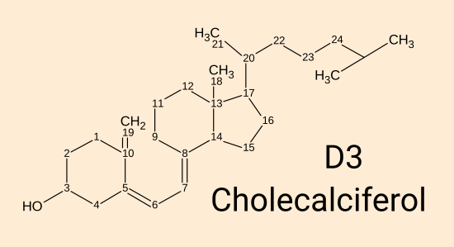
D3 cholecalciferol. [WP] is produced by the approximately 295 to 297 nanometre wavelength range of UV-B light acting on 7-dehydrocholesterol in the skin. It can also be ingested in food or supplements. While this plain D3 directly protects the endothelial cells which line our blood vessels [Gibson et al. 2015], all its other currently known roles in the body rely on it being converted primarily in the liver (there may also be some conversion in cells outside the liver), over a period of days to a week, by the enzyme vitamin D 25-hydroxylase (encoded by the CYP2R1 gene, a name sometimes given to the enzyme itself) to the second compound 25-hydroxyvitamin D AKA 25(OH)D. (Another enzyme encoded by the CYP27A1 gene does the same thing and so produces some of the 25(OH)D.)
The numbers indicate carbon positions. Most hydrogen atoms are not shown.
In Nature, in the laboratory and in industry, the only method by which this or similar molecules can be produced is by starting with a molecule with four carbon rings, and then by breaking the double-bond between carbons 9 and 10, to open up the second ring. No chemical reaction can do this. The only way of breaking the bond is with the energy imparted to particular electrons by 295 to 297 nanometre UV-B light.
Ultraviolet-A light - 315 to 400 nanometre wavelength - is shorter wavelength (higher frequency, higher energy induced in electrons) than visible violet. The light which creates D3 falls within the UV-B band, 280 to 315 nm. This is right at the limit of the Sun's shortest wavelengths and is attenuated both by the ozone layer and the lower atmosphere. All UV-B light breaks bonds in other biological molecules, such as DNA, and so damages genetic information in our cells and predisposes them to cancer.
Industrially, D3 is produced in a handful of highly specialised factories, with most production being for agricultural animals. The factories which produce pharma-grade D3 are primarily in India and Europe. None are in the Americas or the British Isles. 7-dehydrocholesterol, prepared in a series of chemical steps, from woolfat, is dissolved in benzene and irradiated with specialised multi-kilowatt mercury vapour lamps which have been doped to produce the requisite wavelengths. A full account of industrial production of vitamin D3 is Industrial Aspects of Vitamin D by Arnold L. Hirsch in 2010 : https://sci-hub.se/10.1016/B978-0-12-381978-9.10006-X .

Fermenta Biotech in India is one of the few companies worldwide who produce pharmaceutical grade vitamin D3 cholecalciferol, though most of their production is for agriculture.
None of these vitamin D3 factories are owned by the major multinational pharmaceutical companies. Industrial production requires a lot of electricity and is highly competitive. Pharma grade vitamin D3 sells for around USD$2500 per kg, which is just under £2 per gram. For a 70 kg non-obese person to maintain healthy 125 nmol/L 25(OH)D levels, 0.125 mg (5000 IU) vitamin D is required a day. This is a gram every 22 years.
Raw vitamin D3 is produced in the same way, and sometimes in the same factories, for agricultural and human use. The latter is refined more carefully.
The SI [WP] units for measuring D3 supplemental intakes are milligrams and micrograms, mg and μg respectively, where the Greek lowercase Mu is commonly replaced with lower case u. In medicine, micrograms are typically denoted as mcg in an effort to avoid confusion between the two SI units. However, the most common unit for specifying vitamin D3 intakes is a curious unit: the International Unit (IU) [WP]. The very small mass of this unit, for D3, bedevils the field and blight's human health because ordinary healthy daily intakes involve thousands, or tens of thousands, of IU. These scarily high numeric values harm human health by making doctors, regulators and ordinary people unnecessarily wary about recommending the quantities which are required for proper health.
The concept of an International Unit applies to only a handful of nutrients or hormones, and for vitamin D3, one IU specifies 1/40th of a microgram: 1/40,000,000 gram.
DeLuca 2014 History of the discovery of vitamin D and its active metabolites traces the history of its discovery to concern about the very high prevalence of rickets [WP] ("The English Disease") in the UK, especially Scotland, ca. 1914. The molecular structure of 7-dehydrocholesterol and vitamin D3 cholecalciferol was determined in 1937 and until 1968 it was assumed that this D3 molecule was directly responsible for its health benefits, known at the time as enabling proper calcium-phosphate-bone metabolism, specifically by the avoidance of rickets.
The IU for vitamin D arose in the 1920s and 1930s in an international effort to standardise testing of products which contained vitamin D, for the urgent purpose of preventing rickets. Vitamin D's chemical structure was not known and the only way of assaying the vitamin D content of a substance was to feed various amounts of the substance to baby rats, who had been fed a special diet which caused them to develop rickets unless they ingested sufficient vitamin D. These rat assays were the only method available for measuring vitamin D until about the 1960s.
Vitamin D3 cholecalciferol is more soluble in fat than in water, since it only has one hydroxyl group. It is a waxy, semi-crystalline solid at room temperature. It is normally sold diluted in tiny "spray dried" granules of hydrogenated vegetable oil which is solid at room temperature and coated with a starchy powder to stop the granules sticking together. This is put into capsules, made into tablets or added to fortified food. It may also be dissolved in oil.
While levels of D3 can be measured in the blood, this is no clinical significance, since its primary role is to be hydroxylated, primarily in the liver, to 25-hydroxyvitamin D. The half-life of vitamin D3 in the bloodstream is in the order of 4 days to a week. Only about 1/4 of it is converted into circulating 25(OH)D.
A vitamin is an organic molecule which the body needs in small quantities to function properly. Vitamin D3 is arguably not a vitamin, since we can produce all we need ourselves with UV-B exposure of our skin.
However, for most people, it is impossible to obtain all the vitamin D3 they need from UV-B skin because they cannot expose their skin enough all year round. Even if this was possible, it would never be advisable due to the skin damage and cancer risk this would entail over a lifetime. (Here in Australia, everyone knows about skin cancer. Awareness of this is much lower in the UK.) So vitamin D3 can properly be considered a vitamin.
In mammals, a hormone is a substance which, by its level (concentration) in the bloodstream (dissolved in the plasma, rather than being in the blood cells themselves) signals from one part of the body (whatever controls this level) to cells in distant parts of the body, some information which controls the distant cells' behaviour. Hormones may also circulate in the cerebrospinal fluid.
The level of vitamin D3 cholecalciferol in the blood or anywhere else does not signal anything - meaning it does not convey information from one part of the body to another.
Vitamin D3 never acts as a hormone.
A common failing of vitamin D research articles is to refer to vitamin D3, or the three compounds collectively (“vitamin D”), as a "hormone". This is often an attempt to ascribe to it a gravitas it is thought to lack as a mere "vitamin". This is a mistaken description, except in one particular instance, as Reinhold Vieth (above) explains. This common mistake gives rise to unreasonable concerns about vitamin D3 intakes which might be regarded as ingesting a hormone, and so lead to unrealistic fears about toxicity.
D3 does not bind strongly to the Vitamin D Receptor (VDR) [WP] - the large molecule, which when bound to 1,25-dihydroxyvitamin D, alters cell behaviour by up- and down-regulating the transcription [WP] of dozens or hundreds of genes.
Returning to the problems caused by the fact that, when measured in IUs, healthy daily intakes of vitamin D3 involve four of five digits, here are some notes on the physicality of 0.125 milligrams 5000 IU of vitamin D3, which is a healthy daily intake for a 70 kg non-obese person:
This is 1/8000 of a gram, about 1/3rd the mass of a poppy seed.
This is the same mass as that of a 1.25 millimetre square of 80 gsm office paper. (A square with 1/20th of an inch sides.)
An A4 [WP] sheet of office paper weighs 5 grams. (US Letter size is a little smaller.) If we think of this as being made of vitamin D3 cholecalciferol, a 70 kg person not suffering from obesity could healthily chomp through this sheet at one 1.25 mm square per day, consuming the whole sheet after 109 years. Two grains of ordinary table sugar weigh about 1.25 mg, which as D3 is 50,000 IU.
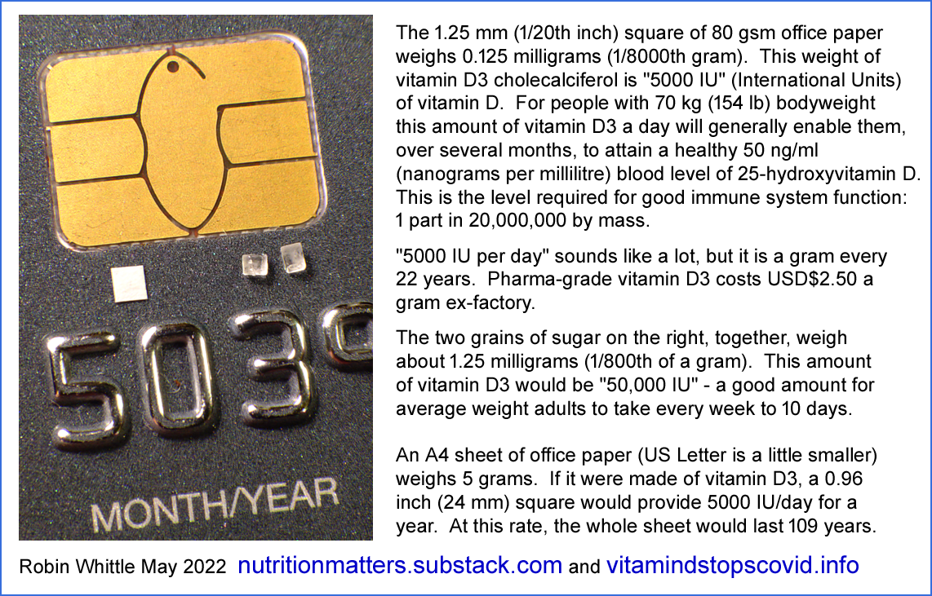

Another quantity worth visualising is the total amount of vitamin D3 a person would consume, over 80 years, when following the UK government's current advice of 0.01 mg 400 IU a day. (For white people this is advised only in winter-spring, but let’s assume they took it every day.) The total is 0.293 grams. This is the mass of 18 grains of jasmine rice. The ex-factory cost of this vitamin D3 would have been about £0.60.
This supports Prof. Martin Hewison's assessment (in the Introduction, above) of the UK government's guidance: "Keep calm and take vitamin D (but make sure that it's the lowest dose possible)."

2.2 25-hydroxyvitamin D calcifediol = 25(OH)D
For brevity, I will generally refer to this compound as 25(OH)D. It is also sometimes referred to as calcidiol, which is a term best avoided, since it looks and sounds too much like "calcitriol".
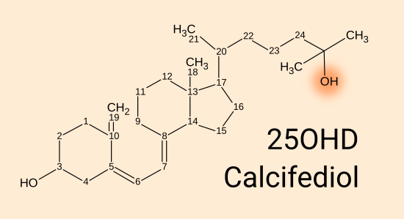
Although very small quantities of 25(OH)D may be consumed in food, such as in the livers of fish, it is not generally regarded as a nutrient or a vitamin.
Oral (or perhaps intramuscular or intravenous) calcifediol is, however, a crucial method of boosting circulating 25(OH)D levels, in 4 hours or so, for clinical emergencies such as COVID-19, sepsis, Kawasaki disease, MIS-C etc. Although medical treatment is beyond the scope of this Call for Evidence, the tremendous benefits of this therapy are discussed in a later section, because they establish beyond doubt how crucial the circulating 25(OH)D level is to the function of the immune system.
In ordinary human life, 25(OH)D is produced by the hydroxylation of vitamin D3 - by replacing a hydrogen at the 25th carbon with an oxygen-hydrogen hydroxyl group. This makes it more water soluble and gives it a totally different role in the body.
This hydroxylation takes place primarily in the liver, over a period of days, though to some extent it can also occur in cells elsewhere in the body. A bolus dose of D3 (such as 10 mg 400,000 IU for 70 kg bodyweight) raises 25(OH)D levels in, very approximately, 4 days - due to the limited amount of the hydroxylation enzyme in the liver and elsewhere.
25(OH)D has a relatively long half-life in the bloodstream. It may also be stored to some extent in tissues. At lower levels, its half-life is several months. Self-limiting mechanisms (primarily a 24-hydroxylase enzyme, whose activity scales with increasing 25(OH)D levels) destroy some 25(OH)D and so make it increasingly difficult to raise its level in the bloodstream, as the level rises. At higher levels, such as 375 nmol/L 150 ng/mL, the half-life is a week or two.
25(OH)D is present in the bloodstream in three arrangements. According to:
Vitamin D Binding Protein, Total and Free Vitamin D Levels in Different Physiological and Pathophysiological Conditions
Daniel David Bikle and Janice Schwartz
Frontiers in Endocrinology, Bone Research 2019-05-28
https://www.frontiersin.org/articles/10.3389/fendo.2019.00317

85% of serum 25(OH)D is strongly bound to Vitamin D Binding Protein (VDBP) [WP] molecules. This evolved from the albumin [WP] proteins, which are the most common proteins in the blood plasma..
15% is more loosely bound to albumin proteins.
0.03% is unbound, freely in solution in the plasma.
25(OH)D can diffuse passively across cell membranes. However, its transport into kidney cells is usually when bound to VDBP.
Vitamin D blood tests measure the total amount of 25(OH)D in the bloodstream, bound and free. It is also possible to measure just the free portion, but this is less frequently used in clinical practice.
Here we encounter two alternative systems of units:
- ng/mL = nanograms per millilitre. This is billionths of a gram of 25(OH)D per gram of blood plasma [WP] - the 95% water fluid which makes up 55% of the volume of the blood, the other 45% comprising blood cells. For instance, 50 ng/mL is one part 25(OH)D by mass to 20,000,000 parts by mass of plasma.
- nmol/L - nano-moles per litre. A mole is an SI unit representing a particular number of molecules: about 6 to the power 23. A nanomole is a billionth of this, so it is, precisely, 602,214,000,000,000 molecules.
The conversion factor with the mass of the 25(OH)D molecule is about 2.5, so 125 nmol/L 25(OH)D is the same as 50 ng/mL 25(OH)D.
nmol/L is most commonly used in the UK, Canada, Australia and New Zealand.
The level of 25(OH)D in the blood plasma or anywhere else does not signal anything within the body. While many cell types work best with a sufficiently high level of circulating 25(OH)D, this level is not signaling information - it is just providing the chemical precursor required for proper cellular operation.
25(OH)D never acts as a hormone.
25(OH)D does not bind strongly to the Vitamin D Receptor (VDR).
The level of 25(OH)D is the best measure of a person's total "vitamin D sufficiency", since vitamin D3 is converted, over a period of days to a week, to the longer-lasting 25(OH)D which supplies the bodily systems which we are most interested in:
- The kidneys, in which the 1-hydroxylase enzyme, the activity of which is tightly controlled by the parathyroid hormone, converts 25(OH)D to a very low level (such as 0.045 ng/mL https://vitamindstopscovid.info/02-autocrine/#02-nothorm) of circulating 1,25-dihydroxyvitamin D, which acts as a hormone (endocrine signaling agent) to control the activities of multiple cell types in distant parts of the body for the purpose of regulating calcium-phosphate-bone metabolism.
- An unknown number of cell types, including many immune cells, which are extra-renal (not in the kidneys) and which can hydroxylate 25(OH)D to 1,25-dihydroxyvitamin D. This 1,25-dihydroxyvitamin D does not act as a hormone. Such cell types may do this for one or both of these purposes:
a - So the 1,25-hydroxyvitamin D binds to VDR molecules inside the same cell. This is properly known as intracrine signaling, but it is also sometimes referred to as autocrine signaling. (Autocrine signaling involves a receptor on the outside of a cell binding to, and so detecting, molecules generated within the cell. There are no known instances of this, but since "autocrine" was a common term which roughly described the actual process, it has sometimes been applied to what Martin Hewison and colleagues described as intracrine signaling.)
b - So some of the 1,25-hydroxyvitamin D diffuses to nearby cells and affects their behaviour. This is paracrine signaling and is used by some types of immune cell to affect other types nearby. Except when immune cells operate pathologically, such as in granulomatous disorders, this diffusion does not significantly raise the much lower level of hormonal 1,25-dihydroxyvitamin D in the bloodstream.
A major failing of the vitamin D research literature is that there is no peer-reviewed journal article which explains vitamin D based intracrine (AKA autocrine) and paracrine signaling. So I made my own tutorial for this purpose: https://vitamindstopscovid.info/02-intracrine/ . Here is one of the illustrations, but please refer to this page for the full explanation.

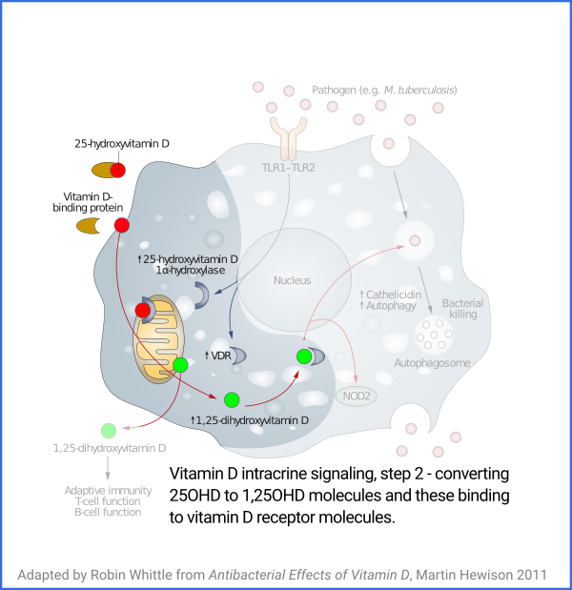

While the kidneys continually maintain a tightly controlled, circulating, level of 1,25-dihydroxyvitamin D, for the crucial hormonal regulation of calcium-phosphate-bone metabolism, the cell types, and individual cells, which use 25(OH)D use it in a completely different way.
All medical professionals understand the kidney system, which is a straightforward hormonal, endocrine regulation, system. To the extent that they are aware of the importance of "vitamin D" to the immune system, it is a common and serious mistake for them to assume that the immune system also works on a hormonal, endocrine, basis. It is not surprising that they think this, since one has to look very carefully at a handful of journal articles to discern that this is not the case.
This leads to a common mistaken belief that the immune system works better with higher levels of circulating 1,25-dihydroxyvitamin D. It doesn't. Leaf et al. 2014 tried forcibly raising circulating 1,25-dihydroxyvitamin D to treat sepsis, and found no benefit. Such treatments are likely to disturb blood plasma calcium levels, which must be maintained within very narrow limits.
Vitamin D's importance to the immune system cannot be understood without clearly recognising that the use of 25(OH)D by multiple types of immune cells works on entirely different principles to those which the kidney uses:
- In vitamin D based intracrine and paracrine signaling, the hydroxylation conversion process is not continual. It is only activated in a particular cell when that individual cell detects a particular condition has occurred. What the condition is varies from one cell type to the next.
- In the case of intracrine (autocrine) signaling, the effect of the just-produced 1,25-dihydroxyvitamin D is to bind to VDR molecules in the same cell, with the bound complexes altering gene expression, and so protein synthesis and the behaviour of the entire cell, in ways which vary from one cell type to the next.
- Likewise, for those cell types which respond to diffused 1,25-dihydroxyvitamin D (produced as just described, in a cell of one type, and which diffuses from that cell into the fluid surrounding it) which reaches them as a paracrine agent (the level of this is much higher than the hormonal 1,25-dihydroxyvitamin D background), the way this changes the behaviour of the cell varies greatly from one cell type to the next.
The way the immune system uses 25(OH)D is completely separate from, and functions on entirely different principles, for entirely different purposes, to the way the kidneys use it.
All medical professionals - and immunologists, endocrinologists, virologists, vaccinologists, epidemiologists and public health officials - need to understand, in broad terms, how full immune system competency depends:
- Entirely on there being good, 125 nmol/L 50 ng/mL levels of circulating 25(OH)D. This does not signal anything. It simply supplies sufficient 25(OH)D to all the cells which need it, and maintains this supply when it is consumed within each cell when its intracrine/paracrine signaling system is activated.
- Not at all on the very low and stable level of circulating, hormonal, 1,25-dihydroxyvitamin D.
Once this is understood, and it is recognised that toxicity may only become a concern for 25(OH)D levels of 375 nmol/L 150 ng/mL or above, it can be seen that proper immune system health can only be assured with 25(OH)D levels of 125 nmol/L 50 ng/mL or more, and that this or double to probably triple, this level, will not cause toxicity, or disturb the hormonal regulation of calcium-phosphate-bone metabolism.
Please refer to this recent review of vitamin D based intracrine and paracrine signaling by Martin Hewison and colleagues.

Autoimmune disease and interconnections with vitamin D
Jane Fletcher, Emma L Bishop, Stephanie R Harrison, Amelia Swift, Sheldon C Cooper, Sarah K Dimeloe, Karim Raza and Martin Hewison
Endocrine Connections 2022-03-31
https://ec.bioscientifica.com/view/journals/ec/11/3/EC-21-0554.xml
Fletcher et al. address autoimmune diseases, but the same mechanisms enable immune cells to respond correctly to produce healthy innate and adaptive immune responses to viral, bacterial and fungal pathogens.
Most of the early work on vitamin D based intracrine and paracrine signaling was done by Martin Hewison and colleagues in the mid to late 2000s, with macrophages [WP] and dendritic cells [WP].

#chauss
A spectacular advance in this field, cited in the above, is the work of Chauss et al. who researched the failure of Th1 regulatory lymphocytes [WP] from the lungs of hospitalised COVID-19 patients to turn off their pro-inflammatory startup program, when they detected the external signal to do so. They should turn this off and transition to an anti-inflammatory shutdown program. This failure was found to be due largely or solely to inadequate supplies of 25(OH)D:
Autocrine vitamin D signaling switches off pro-inflammatory programs of Th1 cells
Daniel Chauss, 26 other authors and (lead authors) Majid Kazemian and Behdad Afzali
Nature Immunology 2021-11-11
https://www.nature.com/articles/s41590-021-01080-3
This is a dense cell biology article, which likely exceeds the expertise and/or patience of most medical doctors. You may wish to refer to my summary of the preprint version of this article, at: https://aminotheory.com/cv19/icu/#2021-Chauss . The term "autocrine" is not quite correct - the processes described are properly known as intracrine signaling.
The proper functioning of the immune system depends on 125 nmol/L 50 ng/mL or more 25(OH)D circulating in the blood serum. Since most people do not naturally get enough vitamin D to attain this, the health of all humanity depends on most doctors, immunologists understanding this by familiarising themselves with vitamin D based intracrine (AKA autocrine) and paracrine signaling, so they can advise governments and individuals on the best way of attaining these levels..
The above two articles are crucial to developing this understanding.
Neither refers directly to the requisite 25(OH)D level, but you can see from Quraishi et al.'s graph (at the start of this submission, and discussed below further) and from numerous observations, such as of 25(OH)D level vs. COVID-19 severity, that 125 nmol/L 50 ng/mL is the proper minimum level, NOT 75 nmol/L 30 ng/mL recommended by the Endocrine Society and especially NOT the lousy 50 nmol/L 20 ng/mL level of vitamin D deficiency which is currently recommended by the UK government.
The Endocrine Society's recommendation for 30 ng/mL 75 nmol/L 25-hydroxyvitamin D as the threshold of vitamin D deficiency was published in 2011 and remains current to this day:
Evaluation, Treatment, and Prevention of Vitamin D Deficiency: an Endocrine Society Clinical Practice Guideline
Michael F. Holick, Neil C. Binkley, Heike A. Bischoff-Ferrari, Catherine M. Gordon, David A. Hanley, Robert P. Heaney, M. Hassan Murad and Connie M. Weaver
Journal of Clinical Endocrinology & Metabolism 2011-07-01
https://academic.oup.com/jcem/article/96/7/1911/2833671
On the dangers of toxicity, due to destablising blood plasma calcium levels (which must be tightly regulated) due to excessive 25-hydroxyvitamin D, the Endocrine Society guidelines state:
Although it is not known what the safe upper value for 25(OH)D is for avoiding hypercalcemia, most studies in children and adults have suggested that the blood levels need to be above 150 ng/mL [375 nmol/L] before there is any concern.
Unfortunately, the next sentence, without any justification, provides a 33% lower threshold which many doctors have regarded as an upper safety limit:
Therefore, an UL of 100 ng/mL [250 nmol/L] provides a safety margin in reducing risk of hypercalcemia.
This arbitrarily low threshold is one of the reasons for unjustified concerns about vitamin D toxicity.
Calcifediol (the pharmaceutical name for 25-hydroxyvitamin D) is produced industrially, in China and Europe, primarily for agricultural animals. Smaller quantities of pharma-grade calcifediol are produced, using a yeast-based process with UV-B, by DSM in Europe https://www.dsm.com . DSM sell it without prescription as a nutrient - a nearly instantly absorbed alternative to vitamin D3 for raising and sustaining 25(OH)D levels. Spanish company Faes Farma sell a prescription form in Spain and Italy.
https://shop.fortaro.com/products/fortaro
https://dvelopimmunity.com/products/vitamin-d-times-three
https://profesionalessalud.faesfarma.com/productos-old/hidroferol/
https://vitamindstopscovid.info/04-calcifediol/
Calcifediol was used to rapidly boost 25-hydroxyvitamin D levels in hospitalised COVID-19 patients, with great success. See Castillo et al. 2020, below: #castillo.
While calcifediol is a uniquely rapid way of boosting 25(OH)D levels in clinical emergencies, I know of no evidence which indicates it is more suitable for long-term nutrition than vitamin D3 cholecalciferol. It is not normally regarded as a nutrient. It is not a drug. Nor is it a vitamin. It is not a hormone since its level in the blood does not convey information - it does not signal anything to any cells.
The concept of International Units is not normally applied to calcifediol. However, in the long term, in regular daily use, 100 micrograms (for instance) of calcifediol per day is about as effective at raising 25(OH)D as (very approximately) 400 micrograms per day of vitamin D3. Even with this greater efficiency per unit mass, calcifediol's more than 4 times higher price makes it less cost effective than vitamin D3.

2.3 1,25-hydroxyvitamin D calcitriol = 1,25(OH)²D
For brevity, I will generally refer to this as 1,25(OH)²D.
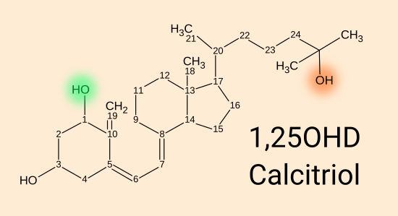
Most of what you need to know about this compound is in the previous sub-section.
It is produced in multiple cell types by the 1-hydroxylase enzyme attaching a hydroxyl group in place of the hydrogen at the number 1 carbon of 25(OH)D.
This completely alters the molecule's behaviour. 1,25(OH)²D binds strongly to the VDR (vitamin D receptor) molecule. So it often referred to as "activated vitamin D".
The kidneys maintain a very low, stable level of 1,25(OH)²D circulating in the bloodstream, where it functions as a hormone, enabling the kidneys (responding to the parathyroid hormone level) to control the activity of multiple cell types all over the body regarding the absorption and excretion of calcium and phosphate, the levels of these in the bloodstream and the constant building and destruction of bone, by osteoblasts and osteoclasts respectively, which is essential for bone health. All medical professionals, immunologists etc. understand this well.
1,25(OH)²D can also function, as described above, as an intracrine (AKA autocrine) agent and as a paracrine agent.
In the bloodstream, hormonal 1,25(OH)²D (whose level is controlled by its production in the kidneys, even if some of the circulating 1,25(OH)²D leaked from cells which produced it as an intracrine/paracrine agent) has a half-life of a day or less. This hormonal level is typically around 0.11 nmol/L 0.045 ng/mL (See https://vitamindstopscovid.info/02-autocrine/#02-nothorm for references,)
The kidneys can generally maintain this as long as they have something in the order of 50 nmol/L 20 ng/mL circulating 25(OH)D, though they generally do it better with higher levels. So the current UK standard of vitamin D sufficiency (50 nmol/L 25(OH)D is reasonable for bone health. However, this standard is only 40% of what is required to assure proper immune system function.
The enzymes in the bloodstream which degrade 1,25(OH)²D are also active in cells in which it is used as an intracrine / paracrine agent. This mops up 1,25(OH)²D quickly, ensuring that once its intracellular production ceases, its activation of VDR molecules also ceases in a timely manner, turning off the changes to cell behaviour which occurred due to many VDR molecules being activated. (The precise details of how the bound 1,25(OH)²D-VDR complexes work within the nucleus to alter gene expression are complex, beyond the scope of this submission and need not be understood by medical professionals. I am not sure of the lifetime of the bound complexes. However, the nature of the timely responses which result from intracrine and paracrine signaling means the complexes must have a limited lifetime.)
1,25(OH)²D is not a nutrient, a vitamin or a drug. It can be used as a medication to make up for the failure of kidneys to maintain the proper hormonal 1,25(OH)²D level.
While it is possible to clinically measure its level in the bloodstream, this gives us information about the regulation of calcium-phosphate-bone metabolism, and tells us nothing about the operation of the immune system.
All the above material about calcium-phosphate-bone metabolism is well known to medical professionals and is not contentious.
The material about the immune system is based on research in the last 15 years, which only partly covers the full scope of the vitamin D compounds in the immune system and in the still less researched cell types outside the immune system which also use vitamin D based intracrine and/or paracrine signaling. This material is generally not known by medical professionals, and there are many MDs and researchers who publish research articles on vitamin D who have little or no awareness of these observations and principles.
However, humanity absolutely depends on good 25(OH)D levels - and will only have these levels in general once most health professionals, immunologists, virologists etc. develop a proper understanding of vitamin D based intracrine/paracrine signaling, at least as it is used in the immune system.

#03-uk-low

3 - Terribly low 25-hydroxyvitamin D levels in the UK
Most UK citizens, all year round, have 25-hydroxyvitamin D levels far below the 125 nmol/L 50 ng/mL needed for proper immune system function. This has pervasive negative health consequences from early in-utero development to old age - as discussed in Section 4.
Section 5 outlines how current, completely inadequate, UK government vitamin D guidance arose.
The only solution to this is for most people to properly supplement vitamin D3, all year round, with (in the absence of medical advice to the contrary) the daily intake quantity being set by a ratio of bodyweight and whether the person suffers from obesity. This is the subject of section 6 below.
Section 7 explains why healthy 25-hydroxyvitamin D levels cannot be attained through food fortification alone - and furthermore why all government efforts should be directed to supplementation, and none to fortification.
Section 8 discusses how government standards and support for education and provision of proper supplemental vitamin D can solve these problems and ensure that most UK citizens have the 25-hydroxyvitamin D levels they need for full immune system health.
The following graph depicts UK BIOBANK observations of 40 to 69 year olds between 2006 and 2010: Sutherland et al. 2020: https://sci-hub.se/10.1016/j.clnu.2020.11.019 .
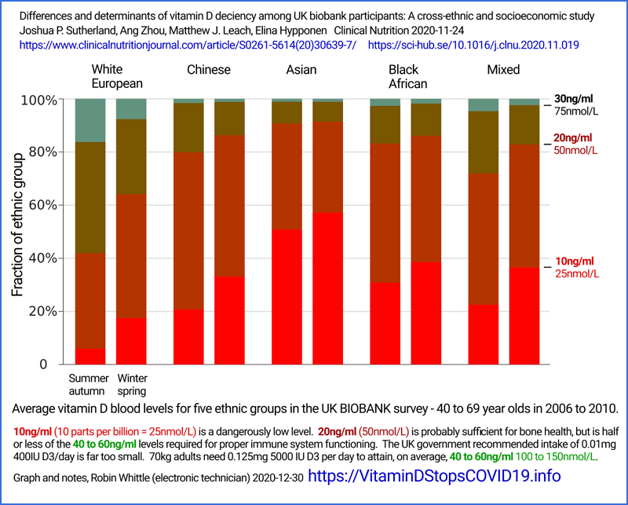
Hopefully present-day levels in this and other age-groups would be higher, but we need not just marginal change from the levels depicted above, but a nation-wide transformation.
Even among white-skinned people, only about 10% of the subjects had 25(OH)D levels above 75 nmol/L 30 ng/mL in winter-spring. So it is reasonable to assume that only 2 or so percent of these people had 25(OH)D levels of 125 nmol/L 50 ng/mL or more, which their immune systems need to function properly. The situation was far worse, all year round, for all those people surveyed who had darker skin and/or whose culture and clothing resulted in less direct, high-elevation, sunlight reaching their skin than the already low amount which, on average, reaches Caucasians' skin.
From the same article:
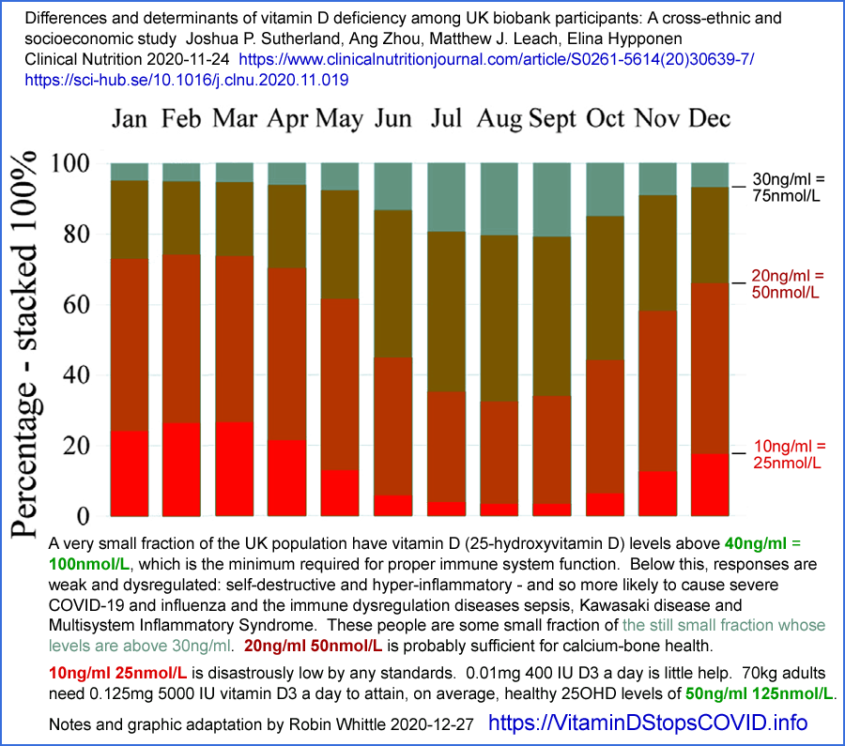
Here is another analysis of the BIOBANK data, from:
Very high prevalence of 25-hydroxyvitamin D deficiency in 6433 UK South Asian adults: analysis of the UK Biobank Cohort
Andrea L. Darling, David J. Blackbourn, Kourosh R. Ahmadi and Susan A. Lanham-New.
British Journal of Nutrition 2020-07-22
https://doi.org/10.1017/S0007114520002779
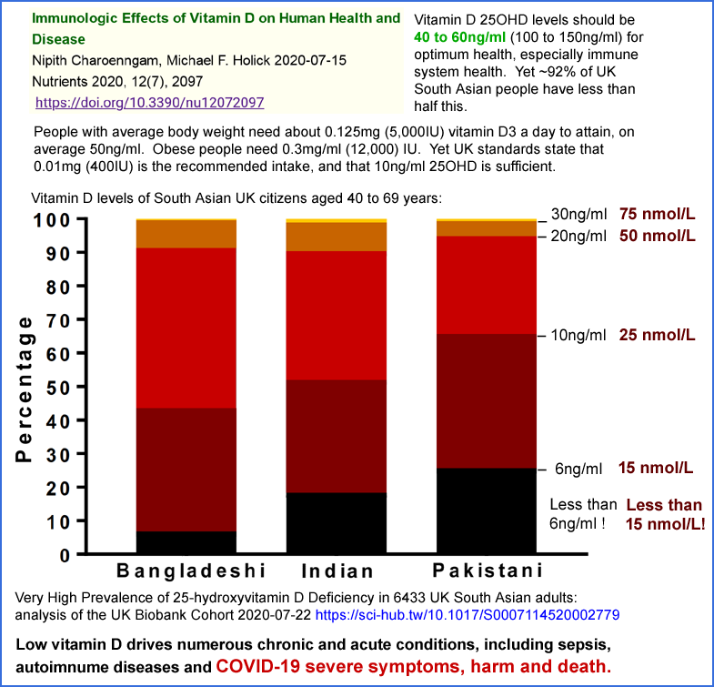
About half of these people have 1/5th or less of the 25(OH)D their immune systems need to work properly.
The impact of the UK's great distance from the equator - 50° to 59° - is evident even within the British Isles in these maps depicting average 25(OH)D levels:
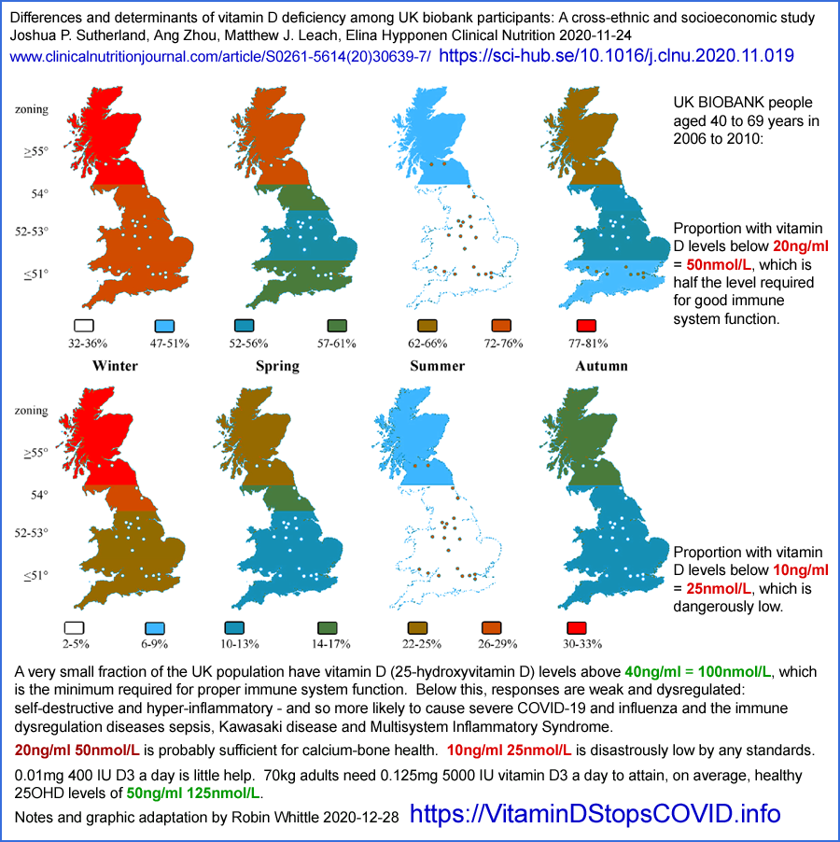
Here is another depiction of the seasonality of average 25-hydroxyvitamin D levels in the UK, again from BIOBANK data. Here I have copied the vector-based graphs from the article and enlarged and annotated them, so they are larger but still precise. This is from Raisi-Estrabragh et al. 2020 https://doi.org/10.1093/pubmed/fdaa095 .
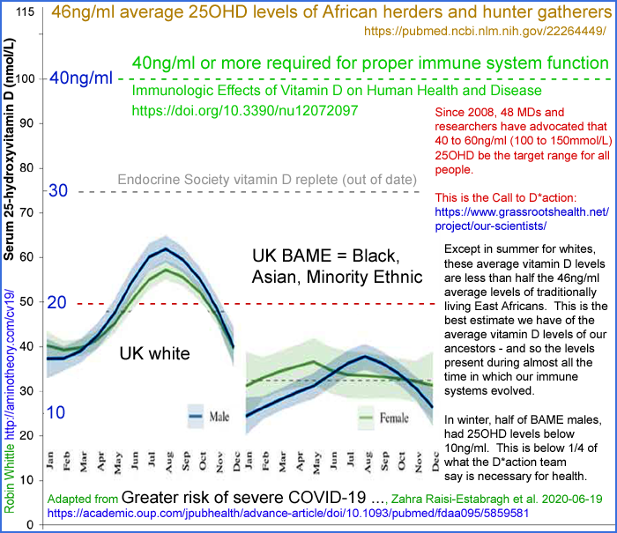
Note that this chart doesn't extend quite to the 125 nmol/L 50 ng/mL level now widely recognised as required for proper immune system function. I made this chart in mid-2020, before becoming aware of Quraishi et al. 2014. According to this BIOBANK data, average white 25(OH)D levels briefly approach half that level. Average BAME levels are a quarter of what is required for good immune system health.
The impact of sun-avoidant clothing and cultural norms is especially evident in the following histograms depicting distribution of 25(OH)D levels in Israel, from:
The link between vitamin D deficiency and Covid-19 in a large population
Ariel Israel et al. 2020-09-07
https://www.medrxiv.org/content/10.1101/2020.09.04.20188268v1
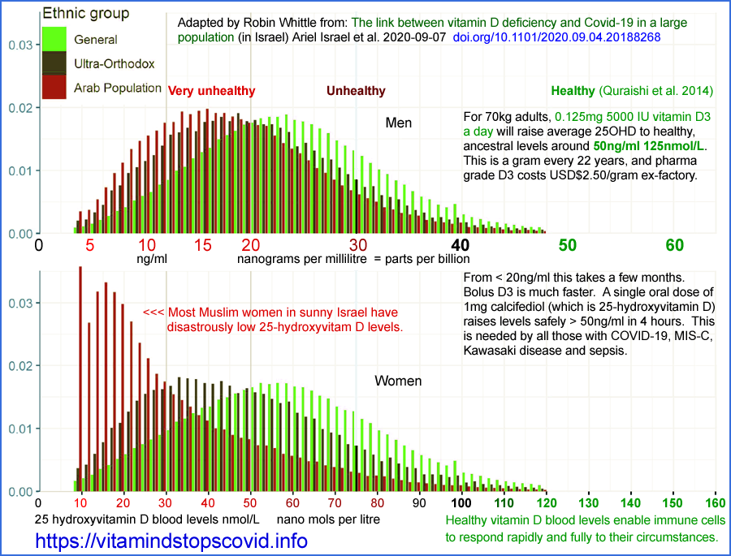
Despite being much closer to the equator - 30° to 33° - almost no Israelis, who mainly have white skin, attain 125 nmol/L 50 ng/mL 25(OH)D. People are wisely advised to avoid direct UV-B exposure in order to protect against skin cancer.
My reason for including these histograms is to draw attention to the extreme ill-effects of cultural practices and clothing which even further reduce the skin's exposure to UV-B light from the Sun. Ultra-orthodox men and women of the primarily white "general" (Jewish) population have somewhat lower 25(OH)D levels, presumably due to sun avoidant behaviour and clothing.
The same can be said of Arab men, who may also on average have more melanin-rich skin, and so who create less vitamin D3 cholecalciferol for any given amount of UV-B skin exposure.
The most striking histogram is that of Arab women. The extreme preponderance of low 25(OH)D levels with respect to those of Arab men is surely explained by their proclivity to wear full body covering clothing and to avoid sun exposure in general.
The left bar (10 nmol/L) for Arab women is higher than the trend curve because some women have levels below this detection limit.
To whatever extent women in the UK avoid direct high elevation sun exposure of their skin, for cultural or other reasons, we can expect their 25(OH)D levels to be even lower than in Israel due to sunlight in the UK always arriving at lower angles from the horizon, which strongly attenuates its UV-B content.

3.1 Comparing UK 25(OH)D levels with those of our African ancestors
The only indication we have of the 25(OH)D levels of our African ancestors, prior to the development of modern clothing and migration far from the equator, is a small series of measurements taken from traditionally living East African Maasai herders and Hadzabe hunter gatherers:
Traditionally living populations in East Africa have a mean serum 25-hydroxyvitamin D concentration of 115 nmol/L (46 ng/mL)
Martine F Luxwolda, Remko S Kuipers, Ido P Kema, D A Janneke Dijck-Brouwer and Frits A J Muskiet
British Journal of Nutrition 2012-01-23
https://doi.org/10.1017/S0007114511007161

We measured the sum of serum 25-hydroxyvitamin D2 and D3 (25(OH)D) concentrations of thirty-five pastoral Maasai (34 (sd 10) years, 43 % male) and twenty-five Hadzabe hunter–gatherers (35 (sd 12) years, 84 % male) living in Tanzania. They have skin type VI, have a moderate degree of clothing, spend the major part of the day outdoors, but avoid direct exposure to sunlight when possible.
The average 25(OH)D level was 115 nmol/L 46 ng/mL
Fitzpatrick skin type VI (6, of 1 to 6) is the darkest type. Images from the UK: https://www.sungoddesskin.co.uk/what-skin-type-are-you/ Sachdeva 2009:
Dark brown to black. Never burns, tans profusely.
From this we can see that white-skinned people living in sunny Israel are highly 25-hydroxyvitamin D deficient with respect to the African people sampled by Luxwolda et al. - and that (without proper vitamin D3 supplementation) almost everyone in the UK is even more deficient.
This sample of 60 Africans is the best information we have about ancestral 25(OH)D levels. We should not assume that these African levels are optimal for all people, such as those in the UK today. Vitamin D3 is a vital compound for general health, but - since there is very little in food - without supplements it can only be obtained by exposing the inner layers of the skin to UV-B radiation around 290 to 315 nanometres wavelength (in order to get the necessary light around 295 to 297 nm), which always damages DNA and so raises the risk of skin cancer.
This cancerous trade-off in producing vitamin D3 is an argument that the long-evolved production quantities (limited in our African ancestors by intense melanin, evolved for this purpose), and so the resulting levels of circulating 25(OH)D, are lower than the levels which would most benefit health. Humanity may arguably have evolved higher 25(OH)D levels if the requisite vitamin D3 could have been obtained without risk of skin damage and cancer.

The damage begins in-utero
Here is a graph and some quotes from an important UK study:
Failure of national antenatal vitamin D supplementation programme puts dark skinned infants at highest risk: A newborn bloodspot screening study
Suma Uday, Sunia Naseem, Jamie Large, Russell Denmeade, Philippa Goddard, Mary Anne Preece, Rachel Dunn, William Fraser, Jonathan C.Y. Tange, Wolfgang Högler
Clinical Nutrition 2020-12-11 (In press.)
https://www.sciencedirect.com/science/article/abs/pii/S0261561420306671 (Paywalled.)
https://sci-hub.se/10.1016/j.clnu.2020.12.008
Vitamin D deficiency is highly prevalent in all babies born in the UK, especially in winter months. The high proportion of dark-skinned infants with low vitamin D status, demonstrates the failure of the UK's national antenatal supplementation programme in protecting these ethnic groups, who are well recognised to be at a high risk of vitamin D deficiency.

This is from researchers, who like many doctors in the UK, consider 50 nmol/L 20 ng/mL 25(OH)D to be "sufficient". The situation is more alarming still when it is recognised that 125 nmol/L 50 ng/mL is the proper standard of sufficiency.

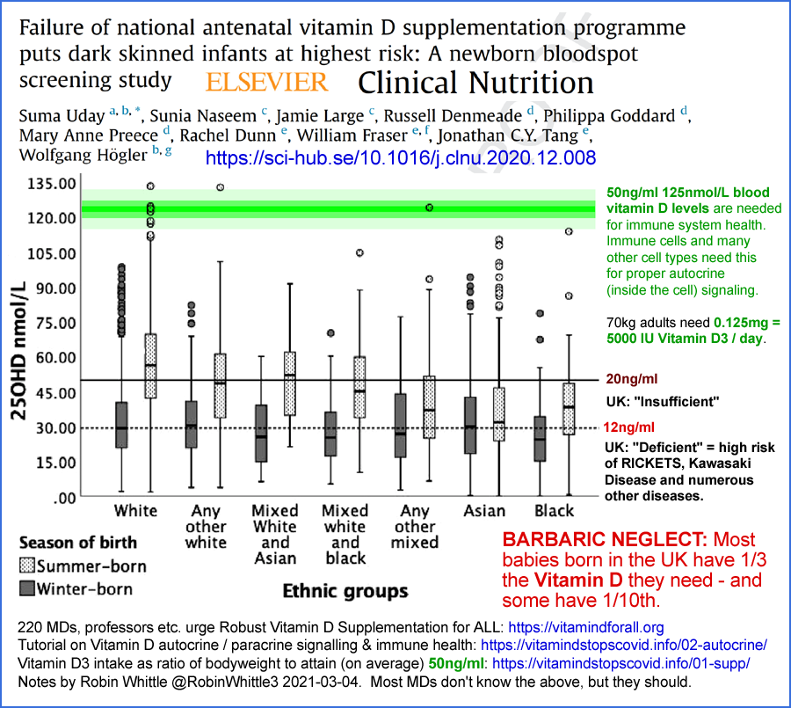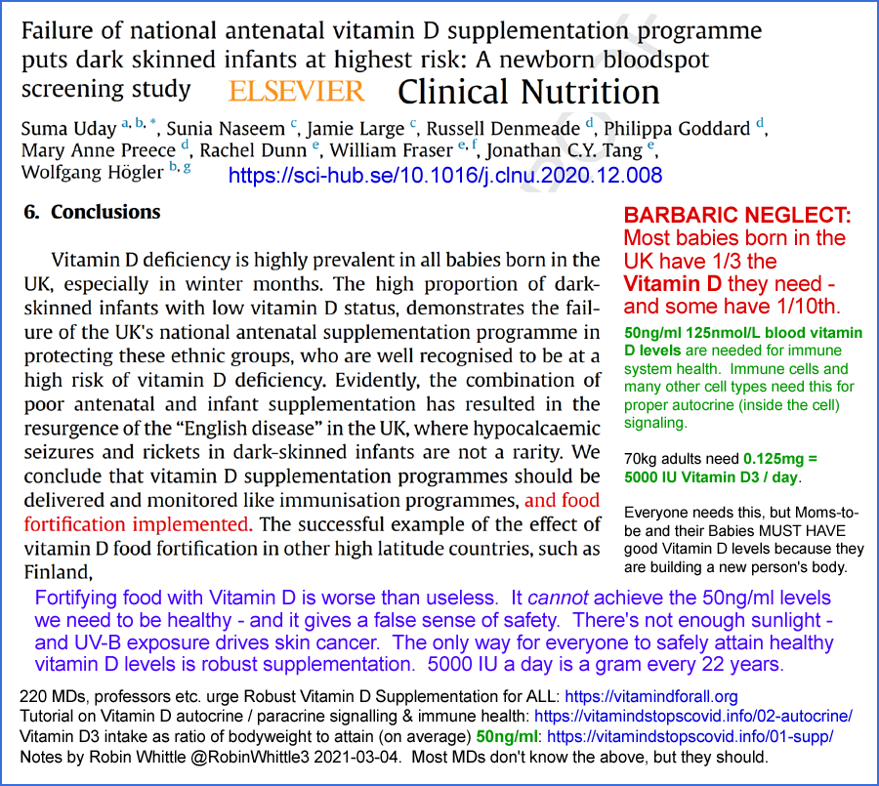

#04-health

4 - The need for 125 nmol/L 50 ng/mL 25-hydroxyvitamin D
There is a vast research literature on vitamin D. Not all of it is particularly interesting - there are too many low-key review articles which add little to our knowledge and which may perpetuate falsehoods, such as "vitamin D is a secosteroid hormone", or which discuss immune system function without clearly identifying the non-hormonal vitamin D based intracrine and paracrine signaling mechanisms which immune cells rely on.
You can use Google Scholar to search for research articles on the relationship between observed or experimentally altered 25-hydroxyvitamin D levels and health outcomes:
Autism
COVID-19 (See also https://vdmeta.com.)
Diabetes
Influenza
Pre-term birth
Psoriasis
Rheumatoid arthritis
etc. etc.
These are a few of dozens of major health problems whose incidence and/or severity are worsened by 25(OH)D levels significantly below 125 nmol/L 50 ng/mL. The best of these research items are linked to from the left column at vitamin D researcher Henry Lahore's https://vitamindwiki.com.
For brevity, this section mentions only a small subset of the relevant research.

4.1 Seasonality and so incidence and severity of influenza
The seasonality of influenza and other viral respiratory diseases has long been known. Though this is often attributed to variations in outdoors temperature and humidity, and to a people spending more time indoors in winter (where most transmission occurs), these mechanisms explain only a small part of the seasonal variations. Indoor and in-vehicle temperatures rise and humidity falls in winter - the opposite to the seasonal changes in outdoor conditions.
The best explanation for this seasonality, in countries far from the equator, is the change in average 25-hydroxyvitamin D levels. Higher 25(OH)D levels in summer and autumn enable better innate and adaptive responses to all kinds of pathogens. This improved immune system competency has at least three effects in whole populations:
- Reduced chance of becoming infected for any given viral insult.
- Reduced severity of symptoms for those infected - including increased chance of no symptoms at all.
- Reduced community-wide rates of transmission due to lower average levels of viral shedding by those who are infected.
The first mechanism is important, but the other two are still more significant. The second affects perceived levels of infection and the level of suffering, harm and death for those who are infected. The third strongly attenuates average rates of transmission and so can prevent pandemic transmission and greatly reduce the number of people who become infected.
The following diagram is based on one originally published in:
The role of season in the epidemiology of influenza
R. E. Hope-Simpson
Epidemiology and Infection 1980-05-22
https://doi.org/10.1017/S0022172400068728

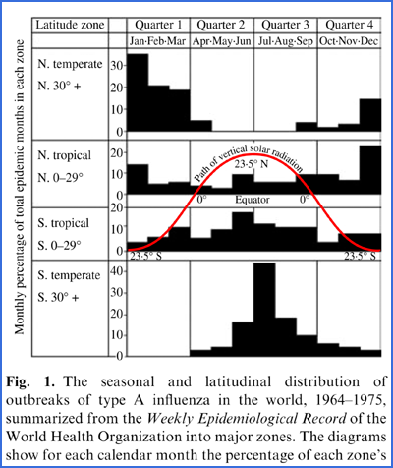

This is from:
Epidemic influenza and vitamin D
J. J. Cannell, R. Vieth, J. C. Umhau, M. F. Holick, W. B. Grant, S. Madronich, C. F. Garland and E. Giovannucci
Epidemiology and Infection 2006-09-07
https://doi.org/10.1017/S0950268806007175
Vitamin D supplementation should stabilize 25(OH)D concentrations consistent with levels obtained by natural summertime sun exposure (50 ng/ml) while avoiding toxic levels. Those with large amounts of melanin in their skin, the obese, those who avoid the sun, and the aged may need up to 5000 IU/day to obtain such levels, especially in the winter.
Cannell et al. also wrote that the hypothesis should be tested:
Are patients with low 25(OH)D levels more likely to contract viral respiratory infections?
This call was answered by:
Reply to: Epidemic influenza and vitamin D
J.F, Aloia and Melissa Li-Ng
Epidemiology and Infection 2007-03-12
https://www.jstor.org/stable/4621170
who reported on a beautifully designed, 3 year long, double-blind [WP], placebo-controlled [WP] RCT (randomised controlled trial [WP]) involving 208 post-menopausal African American women in Long Island, New York State, USA. This diagram explains the results:

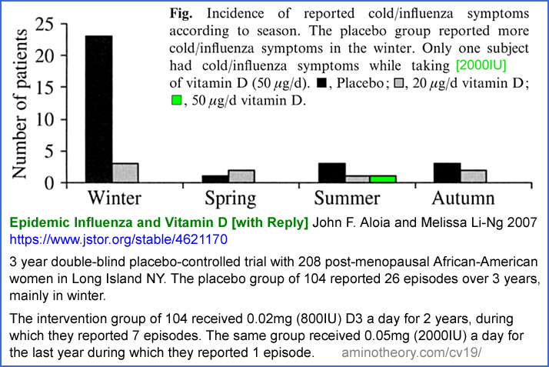

In the intervention group, 0.02 mg 800 IU/day vitamin D3 resulted in 7 infections over two years (grey) with only a little more in winter, while placebo group (black) reported 26 episodes over three years, mostly in winter. In the third year, the same 104 women were given 0.05 mg 2000 IU/day D3 (green) and there was only one episode, in summer.
The very small supplemental intake of 800 IU/day D3 greatly reduced influenza incidence (though asymptomatic infection would not have been detected), and abolished the concentration of cases in winter. Just 0.05mg 2000IU/day D3 almost entirely abolished influenza for these women all year round.
This is not the same as raising the 25-hydroxyvitamin D levels of whole populations, or of the great majority of a population. In this trial, the subjects were living in a generally unsupplemented community and so were at the currently normal risk of being exposed to influenza viruses, which is much higher in winter due to more people being infected then. This trial measured the ability of individuals to avoid symptomatic infection in a setting of unchanged viral insults.
If an entire population raised their 25-hydroxyvitamin D levels in the same way as the women in the intervention group, then we would expect still fewer infections, since all individuals would be less likely to develop symptomatic influenza for any given viral insult. This reduction in symptomatic cases would therefore reduce the average level of viral insult of all people in the population. This and the general reduction in viral shedding by those infected would further reduce transmission and so the total number of infections.
We don’t know the 25-hydroxyvitamin D levels of these women. However, it is reasonable to assume that the placebo group’s levels were around 25 to 37.5 nmol/L (10 to 15 ng/ml) and that intervention group’s levels averaged around 55 nmol/L (22 ng/ml) for the first two years (800 IU/day) and around 95 nmol/L (38 ng/ml) for the third year with 2000IU/day. These are my guesstimates based on the following graph from Gallagher et al 2014: which depicts the 25-hydroxyvitamin D levels for five groups of African American women who were given zero, 0.01mg 400IU, 0.02mg 800IU, 0.04mg 1600IU and 0.06mg 2400IU D3 a day for 12 months.

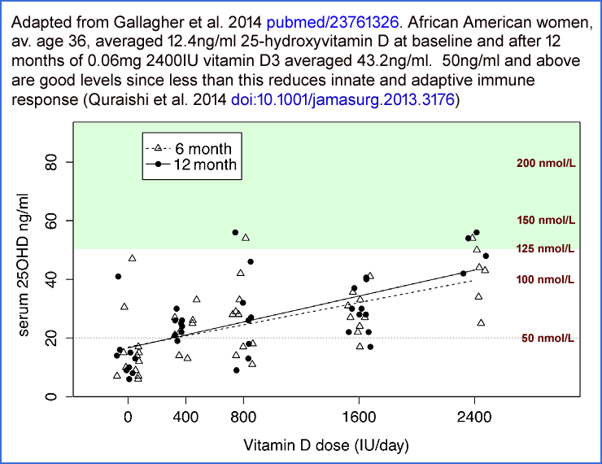

As an aside, the above data shows that:
- The UK government's currently recommended vitamin D supplementation quantity of 0.01 mg 400 IU only raises 25(OH)D levels a small fraction of what they need to be raised in order to attain 50 ng/mL 125 nmol/L.
- Daily intakes of 4 and 6 times this amount (1600 and 2400 IU) do not raise average levels 4 or 6 times as much. This shows that 25(OH)D levels are not proportional to vitamin D3 intake levels. The self-limiting mechanism makes it harder and harder to raise the level as the level gets higher. See the Heaney et al. 2015 and Ekwaru et al. 2014 graphs in a section below: #05-history

4.2 Seasonality and severity of COVID-19 and influenza
An important foundation of the following sub-section is that in COVID-19, the degree of viral shedding scales with disease severity. This is reasonable to expect of any viral disease, and it is confirmed by the following observations by Wang et al. 2020 https://www.jci.org/articles/view/138759 :
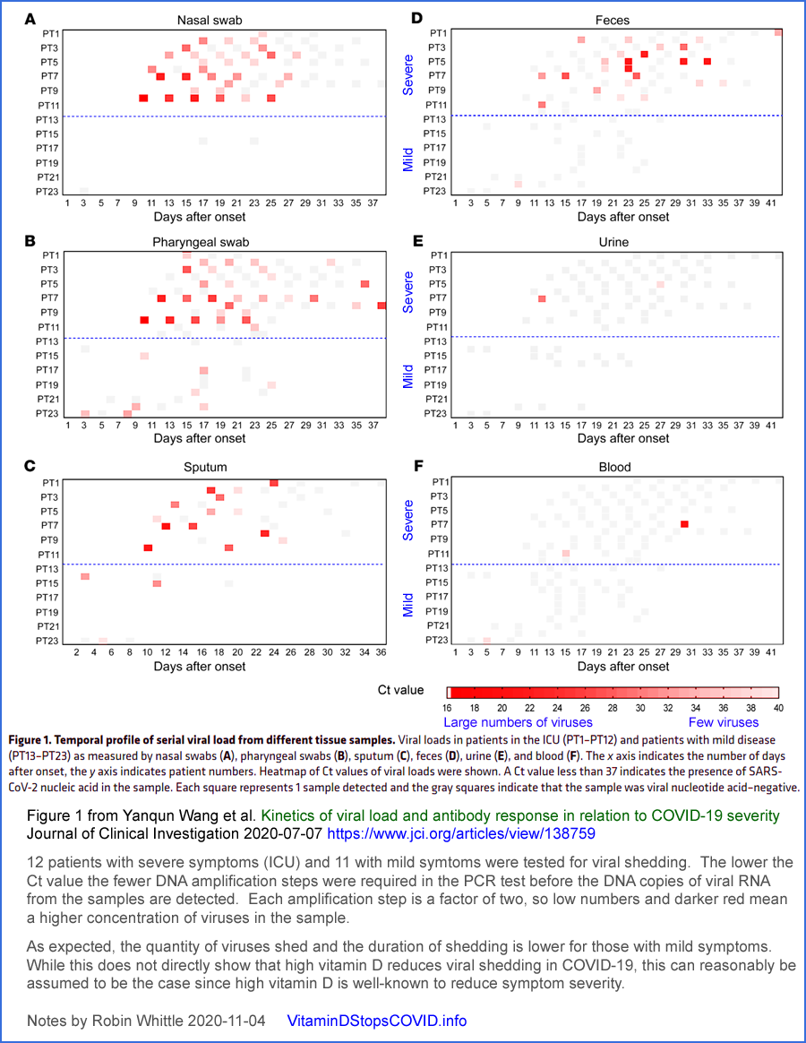
While new, more highly infectious variants in 2021, especially those of the Omicron clade, produced rapidly changing levels of COVID-19 infection, harm and death, a seasonal component to COVID-19 transmission is still evident.
It follows from all we know about:
- The immune system's dependence on good 25-hydroxyvitamin D levels.
- The variation of population average and individual 25-hydroxyvitamin D levels with the season, due to varying levels of UV-B skin exposure,
- The observed inverse relationship between 25-hydroxyvitamin D levels and COVID-19 severity. Please see the graph several pages below showing this relationship, from Vanegas-Cedillo and other research articles.
- Viral shedding increasing according to disease severity.
that COVID-19 transmission, case numbers and the harm and death which results should follow a seasonal pattern like that of influenza.
The following chart depicts this seasonality in action in the UK in the summer of 2020.
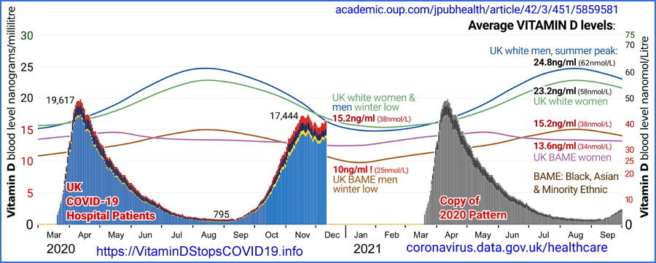
I made this in December 2020 with carefully matched BIOBANK monthly 25(OH)D graphs derived directly (not manually copied) from Raisi-Estrabragh et al. 2020 https://doi.org/10.1093/pubmed/fdaa095 and the hospitalised patients graph from https://coronavirus.data.gov.uk/details/healthcare. The right side is my attempt to predict hospitalised patient numbers in 2021. The hospital patient numbers in blue are all due to the original variant of SARS-CoV-2. B.1.1.7, later known as Alpha, only became significant in the UK in December 2020 [WP].
The graph in blue represents a dramatic seasonal variation in the transmission and severity of the original (in the UK at least) SARS-CoV-2 variant. This was before the introduction of mRNA and adenovirus vector quasi-vaccines directed at COVID-19. There was no early treatment. In the summer of 2020, there were no lockdowns and - as far as I know, little social distancing or adoption of masks.
Something about the UK 2020 summer reduced R0 [WP] to well below 1.0, so the virus was not spreading as an epidemic. If the August 2020 conditions had remained, COVID-19 would have largely or entirely died out in the UK by the end of the year.
We don't know the actual 25(OH)D levels of even a representative sample of UK citizens in the summer of 2020. The BIOBANK graphs give a general indication of seasonal trends.
These 25(OH)D variations, although never approaching what is truly adequate for immune system health, nonetheless are highly significant summer improvements on the lower levels which resulted from limited UV-B exposure in winter and spring.
While the summer solstice at June 21 is the theoretical peak of UV-B availability in the northern hemisphere, actual skin exposure depends also on warmer temperatures, which lag the solstice by a month or two due to the thermal inertia of the oceans. (The lag is a little longer in the southern hemisphere, which has more ocean). Warm temperatures drive more bare skin around midday and so more vitamin D3 for a significant proportion of the population. The liver takes a few days to convert it (actually only about 1/4 is converted) to circulating 25-hydroxyvitamin D and this has a half-life, at these still low levels (compared to 125 nmol/L), of a month or so.
The marginal reduction of time spent in buildings in summer cannot explain more than a small fraction of this drastic attenuation in SARS-CoV-2 transmission. Time spent in vehicles, public and private, would hardly change. There is surely more intermingling between families outdoors in summer than in winter. Direct UV-B inactivation of viruses in aerosols and on surfaces (fomites) may explain some reduction in transmission, but this is only during the day and only outside buildings and vehicles, since UV-B does not penetrate glass.
The only explanation for the great majority of this life-saving reduction in transmission and severity is the population-wide seasonal boost in 25-hydroxyvitamin D levels.
This justifies the Vitamin D Stops COVID name of this website.
To what extent these seasonal variations would prevent pandemic transmission of the much more infectious Omicron variants cannot be implied from these 2020 observations.
However, Patrick W. Chambers and I are advocating that everyone raise their 25(OH)D levels to 125 nmol/L 50 ng/mL or more, all year round. Since even half this level was putting a stop to the original SARS-CoV-2 variant, there’s a good chance it would strongly attenuate transmission of Omicron and future variants to the point of R0 being below 1.0, so there would be no pandemic transmission and so an overall low number of cases.
There have been many academic journal articles concerning seasonality of COVID-19. These are necessarily speculative since we can't experimentally change the seasons. Most of these articles ignore seasonal variations in 25-hydroxyvitamin D levels and focus on outdoors temperature and humidity and related behavioural changes, with conflicting theories and observations. A partial survey of this literature can be found in my Substack article: https://nutritionmatters.substack.com/p/covid-19-seasonality-is-primarily .
From that article, here are some further arguments for proper community-wide vitamin D3 supplementation to defeat the ability of influenza, COVID-19 and other such diseases to spread rapidly at any time of year, and to reduce the harm suffered by those who do contract them.
Even without any knowledge of the mechanisms by which 25-hydroxyvitamin D levels affect disease severity of viral shedding, we can reason that in countries far from the equator:
1 - Seasonal variations in UV-B skin exposure lead to higher levels of 25-hydroxyvitamin D in summer-autumn and lower levels in winter-spring.
2 - Low 25-hydroxyvitamin D levels increase disease symptom severity - especially in influenza and COVID-19.
3 - Viral shedding is reasonably expected to scale with symptom severity. Wang et al. 2020’s observations confirm this.
4 - Since the quantity of viral shedding varies so much, and is a crucial determinant of transmissibility, we can reliably conclude that winter-spring seasonal variations in 25-hydroxyvitamin D, in the absence of robust vitamin D3 supplementation to attain high levels all year round, is a strong driver of transmissibility.
5 - Since transmissibility, for any given level of innate and adaptive immunity in all the individuals in a population, is the primary determinant of how many people are infected in a given time period, we can reliably conclude that, in the absence of robust vitamin D3 supplementation to attain high levels all year round, winter-spring seasonal variations in 25-hydroxyvitamin D levels play a very large role in the total number of people who become infected.
6 - Once infected, disease severity - and so the overall rates of suffering, harm and death - are strongly affected by the effectiveness of any early or late treatments, the most important of which, in the absence of robust vitamin D3 supplementation to attain high levels all year round, is rapid boosting of 25-hydroxyvitamin D above typically low levels such as 5 to 25 ng/mL (12.5 to 37.5 nmol/L) to at least the 50 ng/mL 125 nmol/L level the immune system needs to function properly. nutritionmatters.substack.com/p/calcifediol-to-boost-25-hydroxyvitamin See also Castillo et al. 2020 below #castillo-2.
7 - In the long term, over years and decades, the harm caused by infectious diseases is reduced to the extent that adaptive immune responses to prior infections provide lasting protection against the same or similar pathogens. Higher 25-hydroxyvitamin D levels, by increasing immune system competency, provides better such protection to each individual than is possible if they have low 25-hydroxyvitamin D levels.
8 - To the extent which most or all people in a population properly supplement vitamin D3 to attain at least 50 ng/mL 125 nmol/L 25-hydroxyvitamin D levels, multiple benefits ensue regarding infectious diseases such as influenza and COVID-19, including:
  - Somewhat reduced chance of being infected for any given viral insult, depending on prior immunity.
  - If infected, reduced disease severity, which reduces harm and the risk of death and increased chance that there will be few or no symptoms.
  - If infected, reduced viral shedding, which benefits all those currently uninfected by reducing the rate of transmission. Ideally this results in R0 [WP] below 1.0 so any outbreaks of infection tend to die out.
  - If infected, each individual’s long-term immunity is strengthened regarding the specific pathogen and variants of the one which caused the initial infection.
  - With highly infectious diseases in which sterilising immunity (which completely prevents infection) does not last a lifetime, and which may fade over periods such as months or a few years - as is the case for influenza and COVID-19 - all-year-round high 25-hydroxyvitamin D levels will ensure good immune system competency and prevent the seasonal development of the generally low community immune competency which enables the winter-spring seasonal epidemic outbreaks which currently drive most influenza infection.
(The same pattern of winter-spring seasonality would be more clearly observed with COVID-19 if its variants settled down into changes which avoid pre-existing immunity to some degree without drastically increasing transmissibility. The recent rapid increases in transmissibility with Alpha, Delta and now especially Omicron variants and sub-variants has created new infection waves even at times of seasonally somewhat elevated 25-hydroxyvitamin D levels.)
  - While we can’t be sure that any given level of 25-hydroxyvitamin D and availability of early treatments will thwart epidemic transmission of future SARS-CoV-2 variants, it is obvious that we should do all we can to boost 25-hydroxyvitamin D levels since this is the simplest, safest, least expensive measure we can take to protect against this and numerous other diseases.
The response by most governments and many doctors to influenza and COVID-19 has always been wrong. It would always have been better to boost 25-hydroxyvitamin D levels community-wide with proper vitamin D3 supplementation than to widely deploy vaccines.
It makes no proper sense to vaccinate individuals (which is expensive, invasive and in the case of COVID-19, risky) when their immune systems are not functioning due to an easily correctable nutritional deficiency.
However, this is what has been done with influenza, and now COVID-19 (with poor results in both cases, regarding transmission and protection from severe disease), due to a number of pernicious factors.
First among these is the profitability of vaccines, which drives their promotion.
Second is the widespread attraction many people have to a specific, narrowly targeted, intervention - when simple, broad, nutritional support would be more effective.
Thirdly, it seems that for some vaccines or at least some people, popular notions of them protecting against transmission and severe disease are not supported by all available evidence to the degree to which they had been promised by authorities. (2022-06-05 explanatory note: The excessive faith in COVID-19 vaccines caused some or many people to believe that they did not need early treatment or nutritional improvement and/or that such measures were ineffective and/or that promotion or acceptance of such measures would reduce the uptake of vaccines, which they believed was the only viable way of protecting the whole community. This reduced many people’s ability to benefit from such nutritional and early treatment approaches.)
Please see the research articles cited in my two recent articles which show that the best available observations indicate that influenza vaccines, over many years, do not reduce hospitalisation or death for influenza or similar diseases to any discernible degree:
https://nutritionmatters.substack.com/p/influenza-vaccines-do-not-reduce

https://nutritionmatters.substack.com/p/influenza-vaccines-do-not-reduce-1da
While vaccine efficacy is not directly pertinent to this Call for Evidence, it is important to note that widely held beliefs about vaccines being the best or only way to tackle some diseases are not supported by the best available research. Proper vitamin D supplementation is a much better approach, though it is not promoted by anyone, since no one will make much money from it.
The government's responsibility is to find the best solutions, irrespective of their profitability and the degree to which they are promoted.

4.3 High levels of infection, harm and death among BAME medical staff in the UK
One notorious aspect of the initial COVID-19 wave of 2020 was that 90% of UK doctors who were killed were from "ethnic minorities". The Daily Mail reports on 2020-06-13:
https://www.dailymail.co.uk/news/article-8416895/BAME-doctors-feel-let...checks.html
From this article, here are photos of some of the 300 healthcare staff who have died so far:
These people generally have even lower vitamin D levels than the poor average of Caucasians in the UK. The deaths of doctors can't be blamed on them living in poverty, or in overcrowded conditions.
The widespread ignorance of the importance of vitamin D for the immune system, and the absence of any early treatment - or even vitamin D repletion and effective treatment in hospital - condemned these people to serious harm and death. They were surely highly exposed to the virus while working long hours protecting others.
Even if these people had followed UK government advice and taken 0.01 mg 400 IU of vitamin D3 a day, all year round, their 25-hydroxyvitamin D levels would still generally have been half or less of the 125 nmol/L 50 ng/ml their immune systems need to work properly.

4.4 Observations of 25-hydroxyvitamin D levels and COVID-19 severity
There is a plethora of research articles on this topic. I stopped adding them to my diagram because it was getting too cluttered. Here are a few:
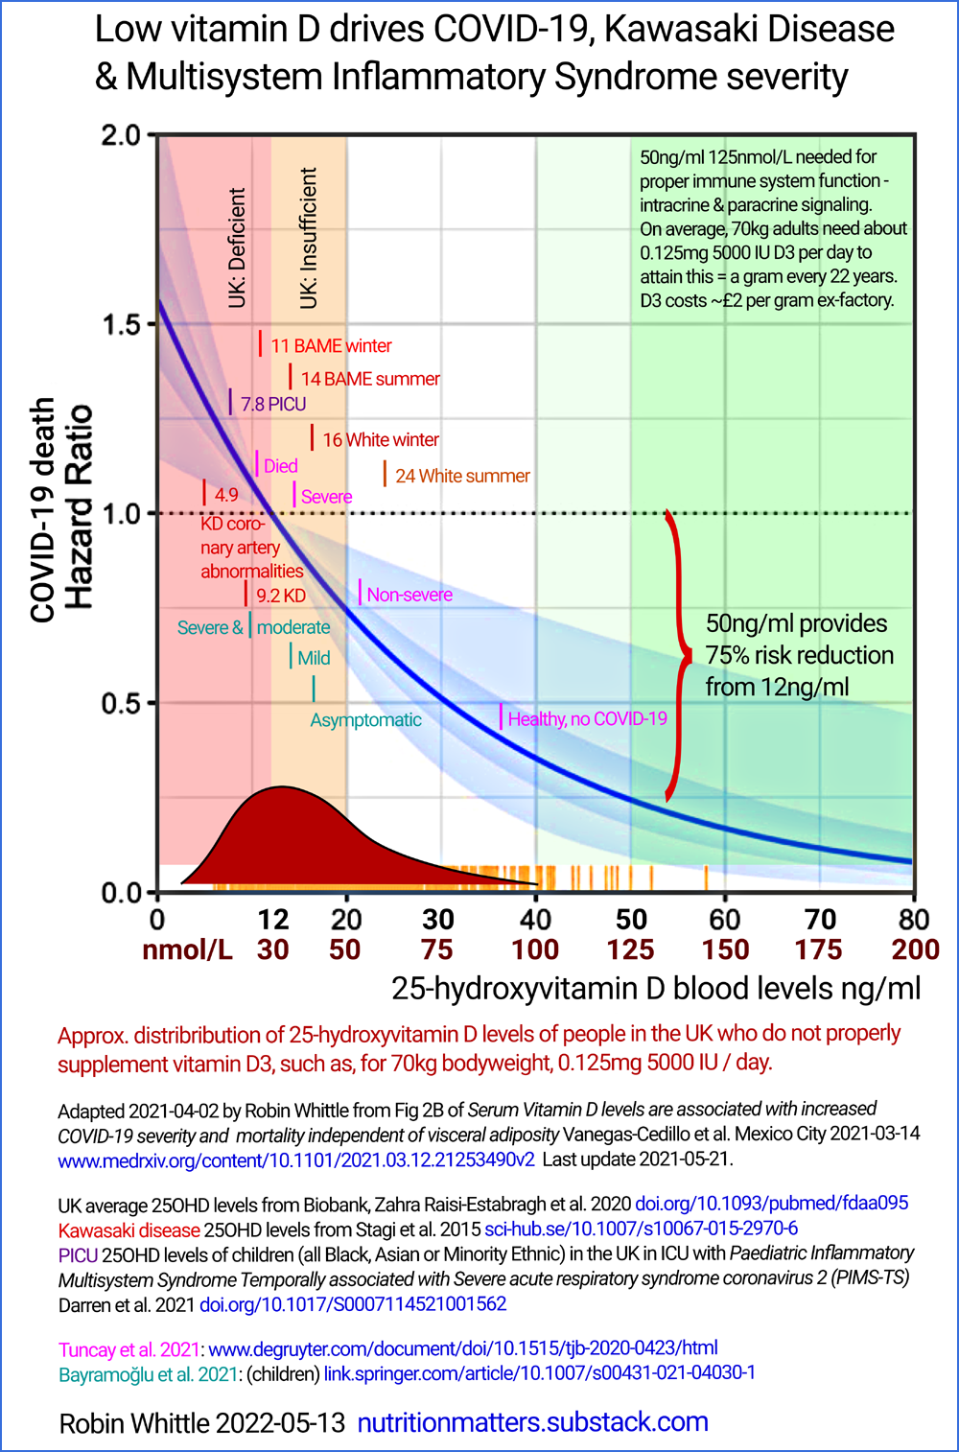
Serum Vitamin D levels are associated with increased COVID-19 severity and mortality independent of visceral adiposity
Vanegas-Cedillo et al. Mexico City 2021-03-14
https://www.medrxiv.org/content/10.1101/2021.03.12.21253490v2
Biobank: #2020-UK-vit-D-BAME .
Vitamin D status of children with Paediatric Inflammatory Multisystem Syndrome Temporally associated with Severe acute respiratory syndrome coronavirus 2 (PIMS-TS)
Angeline Darren, Suma Uday, Deepthi Jyothish and 9 others
British Journal of Nutrition, 2021-05-12
https://doi.org/10.1017/S0007114521001562
The association between vitamin D levels and the clinical severity and inflammation markers in pediatric COVID-19 patients: single-center experience from a pandemic hospital
Elvan Bayramoglu, Gülsen Akkoç, Ayse Agbas, Özlem Akgün, Kamer Yurdakul, Hatice Nilgün Selçuk Duru & Murat Elevli
European Journal of Pediatrics 2021-03-31
https://link.springer.com/article/10.1007/s00431-021-04030-1
For the Stagi et al. 2015 article on Kawasaki disease see the next sub-section.

4.5 Kawasaki disease - and so Multisystem Inflammatory Syndrome AKA PIMS / PIMS-TS
Kawasaki disease (KD) [WP] is an acute inflammatory condition in children, mainly under 5 years, which is triggered by a variety of viral and bacterial infections, though sometimes the triggering condition is not known. KD was first described in 1967 and it is a travesty that most doctors to this day have no idea that low 25-hydroxyvitamin D is a crucial, easily correctable, part of its etiology.
There are dozens of chronic and acute inflammatory autoimmune diseases [GS Google Scholar, 1,950,000 articles]. The primary cause of these is probably that our inflammatory responses - which are indiscriminate cell-destroying responses primarily directed at multicellular parasites - have evolved over tens of millions of years to be stronger than they should be. This is because helminths (intestinal worms), which ubiquitously infected humans until about a century ago, long ago evolved the ability to exude compounds which downmodulate the inflammatory immune responses which threaten their survival.
Human immune systems evolved to be excessively inflammatory so that they were still reasonably effective in the presence of helminthic downmodulation. Now, without helminths, our inflammatory immune responses are prone to being excessively strong, which means that once triggered, they can destroy our own cells to the extent of causing lasting harm or death. The degree to which this occurs varies considerably according to each individual's particular genes.
Two such compounds are currently known, but none are available as medicines to downmodulate our immune responses in the absence of helminths. There are good reasons we eradicated these parasites. However, some of them are relatively benign and the benefits they confer to some people with severe autoimmune disease, such as asthma, rheumatoid arthritis, psoriasis etc. mean that some people deliberately infect themselves with helminths to suppress their symptoms: https://helminthictherapywiki.org . For more information on this, please see the research articles cited at:
https://vitamindstopscovid.info/06-adv/

Low 25-hydroxyvitamin D greatly exacerbates this problem because:
- The resulting immune system weakness results in worse bacterial, viral and fungal infections in general, leading to a greater chance of triggering a self-destructive hyper-inflammatory response.
- The lack of 25-hydroxyvitamin D to supply the intracrine and paracrine signaling systems of immune cells such as Th1 regulatory lymphocytes leads to impaired regulation of inflammatory responses. See Chauss et al. 2021 above #chauss.
Very few doctors or even vitamin D researchers are aware of the problems caused by lack of helminths. See the above web page for Wolday et al. 2021 who report that helminthic infection attenuates the severity of COVID-19. The helminth researchers do not seem to know about vitamin D and the immune system. Many doctors and researchers working on inflammatory disorders have no idea about either vitamin D or lack of helminths.
MIS-C, PIMS and PIMS-TS are synonyms for inflammatory conditions which resemble KD in many ways, but these terms are usually used for diagnosis of older children, teenagers and some young adults, with somewhat different patterns of vasculitis and organ damage. We can reasonably consider these, and KD, to be regions of a single spectrum of wildly dysregulated inflammatory responses, triggered by a typically viral disease.
KD is known to affect children more in winter, to be more likely to affect those far from the equator. It is also well known to be more prominent in children with dark or brown skin. What could be the cause? Doctors regard KD's etiology as a mystery. Yet any London cab driver knows about winter low vitamin D, and every doctor should know that low 25-hydroxyvitamin D leads to weakened innate and adaptive immune responses and to higher risks of wildly dysregulated hyper-inflammatory "cytokine storm" immune responses, which can be triggered by a variety of conditions.
Stagi et al. looked into the matter in 2015:
Severe vitamin D deficiency in patients with Kawasaki disease: a potential role in the risk to develop heart vascular abnormalities?
Stefano Stagi et al. Clinical Rheumatology volume 35, pages 1865–1872 (2015)
https://link.springer.com/article/10.1007/s10067-015-2970-6 (Paywalled.)
https://sci-hub.se/10.1007/s10067-015-2970-6
The patients were 21 girls and 58 boys, average age 5.8 years. Their average 25(OH)D levels were 23 nmol/L = 9.2ng/ml, while age-matched controls averaged 58 nmol/L = 23.3 ng/mL. The average 25(OH)D level of the children who developed coronary artery abnormalities was just 12.3 nmol/L = 4.9ng/ml.
While acute infections can somewhat deplete 25-hydroxyvitamin D, through disturbing its creation from vitamin D3 in the liver and due to more of it being used by the immune system (there's no evidence of this in Han et al, 2016, below), such changes are small compared to the striking, on-average, deficiency of 25-hydroxyvitamin D reported by Stagi et al. It is most persuasive that this deficiency is proportional to disease severity.
It should be obvious that the etiology of KD, MIS-C, PIMS and PIMS-TS is as follows:
- The patient presumably has no helminth infections, and so is prone to excessive, self-destructive, inflammatory responses.
- Since these conditions do not affect most children, or most children with low 25-hydroxyvitamin D levels, it is reasonable to assume that those who do contract the condition probably have one or more relatively unusual genetic factors which make them especially prone to excessive inflammation.
- The children, as a group, have lower 25-hydroxyvitamin D levels compared to controls - and the controls usually have levels which are significantly below the 125 nmol/L 50 ng/mL required for good immune function.
- Their low 25-hydroxyvitamin D levels can reasonably be assumed to drive greater severity of the triggering infection AND more severe dysregulation of the inflammatory response - see Chauss et al. 2021..
Stagi et al.'s article should have become known to all pediatricians and immunologists within months. Unfortunately it is in a paywalled journal, but still this discovery, with obvious, safe, easy to understand and administer clinical implications should have become common knowledge for all doctors within a year or two. However, vitamin D supplementation does not involve the use of any glamorous, supposedly sophisticated techniques or profitable drugs. So no one promotes it.
If most children had at least 125 nmol/L 50 ng/mL 25(OH)D, then it is obvious that the triggering conditions would either not occur, or would be tackled more promptly by the children's immune system. It is also obvious that even with a triggering condition, such children would have much better regulation of their inflammatory response. So the vasculitis, artery and organ damage which characterise these conditions would be far less likely to occur.
Earlier in 2022 I systematically searched for 50 recent articles on these conditions. One mentioned vitamin D in passing and one mentioned it as a possibly causative factor. The other 48 did not mention vitamin D. I intend to write to all the corresponding authors about this. I have never read an account of these children being treated with vitamin D, or calcifediol (25-hydroxyvitamin D). They are treated with anti-inflammatory steroids (which also attenuates innate and adaptive immune responses to bacterial and viral pathogens) and with specialised transfusions: intravenous immunoglobulins [WP] Many of these children suffer lasting heart problems and some die.
This is a travesty. All these conditions are easy to understand, prevent and treat.
We can't give the children helminths. It is not good enough to give them a few thousand IU of vitamin D, which takes days to be converted in the liver to 25(OH)D. Bolus vitamin D3 (such as 2.5 mg 100,000 IU for a small child) would be helpful, but the best response is a single oral dose of 0.014 mg per kg bodyweight calcifediol, which is 25-hydroxyvitamin D, and which goes into circulation in 4 hours, raising levels safely over 125 nmol/L 50 ng/mL and so enabling the immune system to work properly, or at least to work much better than with 1/5 to 1/10th of this, as were the averages reported by Stagi et al.
Treatment for acute disease is beyond the scope of this Call for Evidence. However, the above discussion shows how out-of-touch many doctors are about the importance of good 25-hydroxyvitamin D for the immune system.
Proper vitamin D3 supplementation, for all people (except babies substantially breast fed by vitamin D replete mothers), from birth, will entirely, or almost entirely, prevent these and numerous other diseases.

4.6 25-hydroxyvitamin D repletion in acute disease
Doctors and researchers are often puzzled that attempts to cure acute diseases, including sepsis (which is not a disease as such, but the body's inflammatory responses being so wildly dysregulated as to damage multiple organs) with "vitamin D" do not always produce the desired results.
The reasons for this include:
- By the time treatment commences, a great deal of damage has been done. So perhaps even a complete restoration of immune system competency (or its decisive establishment, for the first time in the person's life) would not be enough to protect the patient from harm or death.
- Many of these trials use far too little vitamin D3 cholecalciferol.
- Even those which use the best possible amount of vitamin D cholecalciferol, such as a bolus dose of 10mg 400,000 IU for 70 kg bodyweight, are not as effective as they ideally would be because the liver (which may be in a severely impaired state) still takes (very approximately) 4 days to convert this into the 25-hydroxyvitamin D the immune system needs. (The kidneys need it too, but they usually maintain their hormonal 1,25-dihydroxyvitamin D output with 50 nmol/L 20 ng/mL 25(OH)D.)
- Very few vitamin D intervention trials for acute diseases use the best possible treatment, which is a single oral dose of (very approximately) 0.014 mg calcifediol per kg bodyweight. This boosts 25-hydroxyvitamin D levels safely over 125 nmol/L 50 ng/ml in four hours or less, without any reliance on the liver. For more information see the Front Line COVID-19 Critical Care Alliance's MATH+ hospital protocol: https://covid19criticalcare.com/covid-19-protocols/math-plus-protocol/ and https://nutritionmatters.substack.com/p/calcifediol-to-boost-25-hydroxyvitamin and Castillo et al. 2020, described below.
Disease treatment is outside the scope of this Call for Evidence, but it is important to note that many doctors' dim view of vitamin D's role in preventing or treating disease is due to intervention trials which do not rapidly replete 25(OH)D levels and due to their own lack of understanding of how the immune system relies on good 25(OH)D levels.
Two highly successful vitamin D based intervention trials (both RCTs) involving vitamin D are as follows. These demonstrate the key role that rapid repletion of 25(OH)D to ca. 125 nmol/L 50 ng/mL plays in tacking medical emergencies which are driven by dysregulated inflammation.
The relative scarcity of such interventions results in or indicates several things:
- Rapid 25(OH)D repletion can bring much superior benefits to conventional steroid-based anti-inflammatory treatments, with few, if any, risks, with low costs and without the numerous problems (psychosis, glucose level excursions driving diabetes, etc.) of conventional treatments. (2022-06-05 note: This first point does not belong in this list, which really has two points.)
- Most doctors do not know that these treatments exist, and are safe, effective, inexpensive and easy to implement. (Multinational pharmaceutical companies have no interest in such research, and benefit from the perception that vitamin D3 and/or calcifediol are ineffective and/or unsafe.)
- The preponderance of RCTs involving low vitamin D intakes and their general lack of decisive success leads to the widespread perception that vitamin D treatment is ineffective in general, or at least in medical emergencies. This is due to lack of knowledge about the liver's slow conversion process and the amount of 25(OH)D which must be generated or otherwise introduced to boost serum 25(OH)D to proper levels, ideally in hours, rather than weeks or months.
One RCT which deserves to be much better known is:
High dose vitamin D administration in ventilated intensive care unit patients: A pilot double blind randomized controlled trial
Jenny E. Han, Jennifer L. Jones, Vin Tangpricha, Mona A. Brown, Li Hao, Gautam Hebbar, Moon Jeong Lee, Shuling Liu, Lou Ann S. Brown, Thomas R. Ziegler and Greg S. Martin
Journal of Clinical & Translational Endocrinology 2016-04-29
https://www.sciencedirect.com/science/article/pii/S2214623716300084
There is a high prevalence of vitamin D deficiency in the critically ill patient population. Several intensive care unit studies have demonstrated an association between vitamin D deficiency (commonly defined as serum 25(OH)D below 20 ng/mL 50 nmol/L) and increased hospital length of stay, readmission rate, sepsis and mortality.
These patients were all severely ill. They were admitted to ICU, expected to require mechanical ventilation for at least 3 days and to remain in intensive care for at least 4 days. 14 were African American, 15 Caucasian and 1 American Indian / Alaskan. Average age was about 62 years.
Patients were administered either placebo, 1.25 mg (50,000 IU) vitamin D₃ or 2.5 mg (100,000 IU) vitamin D₃ daily for 5 consecutive days. There was a significant decrease in the average hospital length of stay in the two treatment groups compared to the placebo group:
n | Total vitamin D3 over 5 days | 25(OH)D  Day 0  ng/mL  nmol/L | 25(OH)D  Day 7 | 25(OH)D  Day 14
10 | Placebo | 21.5  54 | 21.0  53 | 21.3  53
9 | 6.25 mg = 250,000 IU | 23.2  58 | 45.6  114 | 50.5  126
11 | 12.5 mg = 500,000 IU | 20.0  50 | 55.4  139 | 63.6  159

n | Total vitamin D3 over 5 days | Average length of hospital stay  (standard deviation)
10 | Placebo | 36 (19) days
9 | 6.25 mg = 250,000 IU | 25 (14) days
11 | 12.5 mg = 500,000 IU | 18 (11) days

Bolus vitamin D resulted in a dramatic reduction of days in hospital, with statistical significance p = 0.03 (time, log transformed). There is no need to spread the vitamin D over 5 days. Better outcomes would surely have resulted if it was all taken on day 0.
This is a simple, safe and inexpensive intervention. It should be very widely used, except for the fact that it takes the liver (very approximately) 4 days to convert the D3 into circulating 25(OH)D, assuming the liver is functioning properly, which is not at all assured. A superior treatment is a single oral dose of calcifediol, as described next.
It would have been better to boost the patients' 25(OH)D levels earlier in their illness. It would have been better still if they had healthy, 50 ng/mL 125 nmol/L or more 25(OH)D levels all their lives. Then they would have been much less likely to fall ill or (in the case of injuries which trigger sepsis, such as extensive burns) require hospital care for sepsis at all.

#castillo
A more recent RCT involving calcifediol (which is 25-hydroxyvitamin D) with hospitalised COVID-19 patients, in Cordoba, Spain, is well known to vitamin D aware researchers and doctors. It should be known by doctors in general and especially those who treat sepsis, COVID-19, ARDS etc:
Effect of Calcifediol Treatment and best Available Therapy versus best Available Therapy on Intensive Care Unit Admission and Mortality Among Patients Hospitalized for COVID-19: A Pilot Randomized Clinical study
Marta Entrenas Castillo, Luis Manuel Entrenas Costa, José Manuel Vaquero Barrios, Juan Francisco Alcalá Díaz, José López Miranda, Roger Bouillon, José Manuel Quesada Gomez.
Journal of Steroid Biochemistry and Molecular Biology (Prepress accepted 2020-08-29)
https://www.sciencedirect.com/science/article/pii/S0960076020302764
Around April to June 2020, 76 patients admitted to the hospital with confirmed COVID-19 were randomly split into two groups:
26 patients in the control group received no 25(OH)D calcifediol.
50 patients in the vitamin D supplementation group received an oral dose or 0.532 mg 25(OH)D calcifediol (two capsules) on the day of admission, 0.266 mg on days 3 and 7, and then 0.266 mg every week until discharge.
In the long term, oral 25(OH)D calcifediol is very approximately as effective at raising serum 25(OH)D levels as 4 times the mass of vitamin D3. There is no widely accepted conversion ratio by which to estimate the equivalent vitamin D3 amount in IUs for any given quantity of calcifediol. However, if a factor of 4 is assumed, then this initial oral dose is roughly equivalent to 2.128 mg D3, which is 85,120 IU. This amount, as IUs of D3, hardly rates as a bolus dose. (I take 50,000 IU D3 a week - 69 kg BW.)
The unique benefit of calcifediol over vitamin D3 cholecalciferol is that it goes straight into circulation, in 4 hours, as shown in the graph in this patent (page 30 of the PDF), for the same capsules and dose as used in Castillo et al. https://patents.google.com/patent/WO2016124724A1/ .
(2022-06-06 update: A version of the patent graph which shows the times more clearly is now at: https://vitamindstopscovid.info/00-evi/#castillo.)
With oral calcifediol, there is no multi-day delay in the liver or reliance on the liver functioning well. In this trial, there were no measurements of baseline or later elevated 25(OH)D levels. However the authors observe that in winter, the average 25(OH)D level of adults in the Cordoba region is 16 ng/mL 40 nmol/L. (Cordoba is 37° from the equator, far closer than the UK.)
The patent graph shows mean levels in healthy subjects rising from 18 ng/mL 45 nmol/L to 62 ng/mL 155 nmol/L in 4 hours, going above this somewhat, and back to this after 12 hours, then declining slowly to 48 ng/mL 120 nmol/L after 3 days. In the RCT, the subsequent oral doses would have boosted levels significantly on and after days 3, 7, 14 etc.
All patients received hydroxychloroquine and azithromycin. Here are the results:

 | Patients | Did not need intensive care  Number Percentage | ICU | Died in ICU
Control | 26 | 13 50% | 13  50% | 2  8%
Vitamin D | 50 | 49 98% | 1  2% | None

The randomisation resulted in a greater proportion of hypertensive and diabetic patients in the control group, but the authors state that their analysis shows that the protective effects of the calcifediol supplementation remained significant. Age, sex and other comorbidities were in general much the same in the two groups. The validity of these very positive results is supported by a separate analysis by two computational biologist PhDs from MIT.
Mathematical analysis of Córdoba calcifediol trial suggests strong role for Vitamin D in reducing ICU admissions of hospitalized COVID-19 patients
Irwin Jungreis and Manolis Kellis
medRxiv (preprint) 2020-12-21
https://www.medrxiv.org/content/10.1101/2020.11.08.20222638v2
This rapid-acting oral dose of calcifediol boosted 25(OH)D levels about as much as the 500,000 IU bolus D3 doses, over 5 days, in Han et al. 2016. Some part of the dramatic results was due to imperfect randomisation, but the majority was due to the attainment of the 25(OH)D levels the immune system needs in hours, rather than days.
Please remember that most "vitamin D" trials involving acute illnesses involve lower bolus doses of vitamin D3 than Han et. al 2016. None of these D3 interventions are likely to be as effective as a single oral dose of calcifediol as described next.
Both these interventions could easily have used twice the amount of D3 or calcifediol. Toxicity from single doses would probably begin to become a problem with ten to twenty times these amounts.
The Front Line COVID-19 Critical Care Alliance's MATH+ hospital protocol: https://covid19criticalcare.com/covid-19-protocols/math-plus-protocol/ now recommends (following advice of New Jersey Professor of Medicine, Sunil Wimalawansa) a single oral dose of 0.014 mg calcifediol per kg bodyweight, which for 70 kg is 1 mg. The initially boosted 25(OH)D levels are to be maintained by subsequent vitamin D3 doses in the following days. There are no RCTs using this protocol. However, it will surely be more effective than the Han et al. or Castillo et al. interventions, with no risk of toxicity.
There is no need to test 25(OH)D levels before this calcifediol dose. The earlier it is used, the better.
The success of Castillo et al. is the best current measure (after discounting for some of the benefit being due to imperfect randomisation) of the importance of rapidly, within hours, restoring immune system competency by boosting 25(OH)D over 50 ng/mL 125 nmol/L. The benefits of this rapid repletion is the true measure of the importance of good vitamin D levels in illness.
It would be better still if no such interventions were needed, due to all people maintaining such healthy levels through proper vitamin D3 supplementation - meaning that the incidence of such illness will be very much reduced.

4.7 Vitamin D to suppress inflammatory autoimmune diseases
Further to the above discussion of lack of helminths driving excessive inflammation, with low 25(OH)D exacerbating the dysregulated hyper-inflammatory responses, some of the research articles cited at:
https://vitamindstopscovid.info/06-adv/#01-higher
concern the Coimbra, McCullough and Batcheller protocols for treating autoimmune disorders with more vitamin D3 than is required to attain typical healthy 125 nmol/L 50 ng/mL 25(OH)D levels. The protocols include other nutrients, low calcium intake, (in some cases) dietary restrictions and a requirement to drink plenty of water. They are effective against inflammatory autoimmune diseases including:
- Multiple sclerosis. Amon et al. 2022 report mean vitamin D3 intakes of 1.32 mg 52,955 IU/day, and 0.742 mg 29,683 IU/day for the next 6 disorders:
- Rheumatoid arthritis.
- Psoriatic arthritis.
- Connective tissue diseases.
- Plaque psoriasis.
- Inﬂammatory bowel diseases.
- Autoimmune inflammation of the thyroid gland.
- Cluster headaches.
- Migraine.
Such treatment is outside the scope of this Call for Evidence, but we mention it because it is evident that most people's very low 25(OH)D levels surely contribute to the incidence of autoimmune inflammatory disorders in a highly significant way, and that substantial general relief from these could be expected, without the need for medical intervention or supervision, if most people supplemented vitamin D3 properly to attain, in general 25(OH)D levels at or above 125 nmol/L 50 ng/mL.
The list of chronic degenerative diseases in which inflammation plays a crucial role is long and sobering, not least with Alzheimer's disease and other neurodegenerative diseases such as Parkinson's disease and dementia with Lewy bodies.

4.8 Type 2 diabetes, hypertension, breast cancer and cardiovascular disease
This whole section could easily be a dozen times longer.
Please take a look at http://vitamindwiki.com. If even a small fraction of what you read there is true, this is more than enough evidence that the UK government should revise its guidance to encourage and support all people to supplement vitamin D3 sufficiently to attain, in general, at least 125 nmol/L 50 ng/mL 25-hydroxyvitamin D.
Here are four more research items. The text in violet is direct from this Letter, with inline references to the cited research studies.
The emerging evidence for non-skeletal health benefits of vitamin D supplementation in adults
William B. Grant, Barbara J. Boucher, Pawel Pludowski and Sunil J. Wimalawansa
Letter to Nature Reviews Endocrinology 2022-02-22
https://www.nature.com/articles/s41574-022-00646-x
Bill Grant PhD (San Francisco, CV, GS) and Professor of Medicine Sunil Wimalawansa MD (CV, GS) have been researching vitamin D since the 1990s. Barbara Boucher MD of London (CV) has been researching vitamin D since 1970: https://endocrinologyblog.org/2019/10/18/meet-...dr-barbara-boucher/
Randomized clinical trials (RCTs) of vitamin D supplementation were mostly designed to test vitamin D dosage. Heaney’s guidelines for clinical studies of nutrient effects showed that vitamin D supplementation trials should instead be designed and analysed by serum concentrations of 25(OH)D. Data from the D2d study of vitamin D supplementation (4,000 IU per day) in patients with prediabetes were re-analyzed by achieved serum concentrations of 25(OH)D.
Intratrial Exposure to Vitamin D and New-Onset Diabetes Among Adults With Prediabetes: A Secondary Analysis From the Vitamin D and Type 2 Diabetes (D2d) Study
Bess Dawson-Hughes et al.
Diabetes Care 2020-09-16
https://diabetesjournals.org/care/article/43/12/2916/30885/
This re-analysis changed negative overall findings for progression to T2DM after vitamin D supplementation to a hazard ratio (HR) for Type 2 Diabetes of 0.48 (95% CI, 0.29–0.80) for those who maintained 25(OH)D of 100 to 124 nmol/L (40 to 50 ng/mL) and 0.29 (95% CI, 0.17–0.50) for those who maintained 25(OH)D > 125 nmol/L (> 50 ng/mL), compared with 25(OH)D levels of 50 to75 nmol/L (20 to 30 ng/mL) .
One Canadian observational study involving 8,155 participants investigated the association between achieved serum concentrations of 25(OH)D and blood pressure.
Evaluation of vitamin D3 intakes up to 15,000 international units/day and serum 25-hydroxyvitamin D concentrations up to 300 nmol/L on calcium metabolism in a community setting
S. M. Kimball, N. Mirhosseini and M. F. Holick
Dermato-Endocrinology 2017-04-17
https://www.tandfonline.com/doi/full/10.1080/19381980.2017.1300213
Participants were given vitamin D₃ supplements and counseled on how to achieve 25(OH)D levels >100 nmol/L (> 40 ng/mL) . Mean baseline 25(OH)D level was 87 nmol/L, final 25(OH)D was 113 nmol/L and 33% of participants took > 8,000 IU of vitamin D₃ per day. After 1 year, 71% of the 592 participants with hypertension were normotensive, with 13 ± 19 mm Hg and 11 ± 10 mm Hg systolic and diastolic blood pressures, respectively, lower than baseline blood pressures.
Breast cancer incidence was inversely and significantly correlated with serum concentrations of 25(OH)D in a meta-analysis using data from two vitamin D supplementation RCTs and one cohort study.
Breast cancer risk markedly lower with serum 25-hydroxyvitamin D concentrations ≥60 vs <20 ng/ml (150 vs 50 nmol/L): Pooled analysis of two randomized trials and a prospective cohort
Sharon L. McDonnell, Carole A. Baggerly, Christine B. French, Leo L. Baggerly, Cedric F. Garland, Edward D. Gorham, Bruce W. Hollis, Donald L. Trump and Joan M. Lappe
PLoS One 2018-06-15
https://journals.plos.org/plosone/article?id=10.1371/journal.pone.0199265
The pooled cohort included 5,038 women, 77 of whom were diagnosed with breast cancer during the studies. Multivariate Cox regression showed that women with 25(OH)D levels ≥ 150 nmol/L (≥ 60 ng/mL) had a HR for breast cancer of 0.20 (95% CI, 0.05–0.82) compared with women with 25(OH)D levels of ≤ 50 nmol/L (≤ 20 nmol/L).
For myocardial infarction and all-cause mortality, a 20-year retrospective analysis of patients of the US Veterans Health Administration with a baseline 25(OH)D levels of < 50 nmol/L (< 20 ng/mL) with or without counseling to supplement with vitamin D
The Effects of Vitamin D Supplementation and 25-Hydroxyvitamin D Levels on the Risk of Myocardial Infarction and Mortality
Prakash Acharya, Tarun Dalia, Sagar Ranka, Prince Sethi, Olurinde A Oni, Maya S Safarova, Deepak Parashara, Kamal Gupta and Rajat S Barua
Journal of the Endocrine Society 2021-07-15
https://academic.oup.com/jes/article/5/10/bvab124/6321994
showed that those with a serum concentration of 25(OH)D > 75 nmol/L had a propensity-matched HR for myocardial infarction of 0.73 (95% CI, 0.55–0.96) and a HR for all-cause mortality of 0.61 (95% CI, 0.56–0.67), compared with those with 25(OH)D levels < 50 nmol/L.

#05-history

5 - The UK government's current vitamin D recommendations are based on the erroneous 2011 US/Canadian Institute of Medicine report
In 2011 the Canadian and US Institute of Medicine published a massive 662 page report, which has been the foundation for most governments' vitamin D recommendations ever since.
Dietary Reference Intakes for Calcium and Vitamin D
Institute of Medicine (US) Committee to Review Dietary Reference Intakes for Vitamin D and Calcium
Editors: A Catharine Ross, Christine L Taylor, Ann L Yaktine, and Heather B Del Valle.
National Academies Press 2011
https://www.ncbi.nlm.nih.gov/books/NBK56070/
The IOM report contains two enormous blunders:
- The 25-hydroxyvitamin D reference level for vitamin D repletion is set far too low - at 50 nmol/L = 20 ng/mL.
- The Recommended Daily Allowance for vitamin D for adults is set far too low, even for this low 25(OH)D reference level, at 0.015 mg 600 IU.
These egregious, harmful, deadly, blunders have never been corrected.
Governments - or rather governments' advisory committees - choose all the evidence on which they base their final guidance. There is no reason for any government to follow any document or external authority. They tend to do so, to anchor their advice to what they argue, and may believe, is the best available advice of global experts. However, nothing compels any government to follow the IOM's or any other body's advice.
Due to the poor quality of the IOM's work, which is at odds with the recommendation of leading vitamin D researchers - many or most of them medical doctors themselves, and sometimes professors of medicine - governments, especially those such as the UK's government, which is well resourced and has direct access to some of the world’s leading vitamin D researchers in the UK itself, should have developed their own guidance based on the best available research.
The UK government's failure, so far, to do this has cost UK citizens dearly - financially and through general ill-health, suffering, lasting harm and death.
For anyone with moderate expertise and no biases or corrupt interests, it is not hard to understand the immune system's need for 125 nmol/L 50 ng/mL 25-hydroxyvitamin D, or to realise that vitamin D3 supplemental intakes should be specified as ratios of bodyweight to reliably attain these levels in most of the population, without the need for 25(OH)D testing or other forms of medical monitoring.
All the information required to understand this is public, and is cited here. If an electronic technician and computer programmer can put it all together, so should have the various advisory committees, staffed as they are by professional, highly-qualified, researchers and/or clinicians, who are both being paid to do this work and in whom the public places enormous trust.
Leading vitamin D researchers lobbied the IOM to adopt a higher threshold of 25(OH)D repletion, including for the purpose of ensuring good immune system health. However, the IOM refused, and made its recommendations based only on the 50 nmol/L = 20 ng/mL level which it argued is sufficient to supply the kidneys for the purpose of calcium-phosphate-bone and skeletal muscle health.
Below are some of the developments before and after the IOM's report in which researchers argued for a reference level of 125 nmol/L 50 ng/mL or thereabouts.
A Recommended Daily Allowance (RDA) is a quantity of some nutrient which, if consumed by an entire population of adults, ensures that 97.5% of those adults will be sufficient in that nutrient.
This figure is chosen since it means that in the population-wide distribution curve, all those except the people who fall 2 standard deviations below the mean, in whatever measure there is of actual repletion, are the only ones who will not gain sufficient nutritive value from their daily intake.
There is a lot of scatter in individual responses to nutrients and this is especially so with vitamin D3 and the resulting long-term 25(OH)D levels which result from any given vitamin D3 intake for multiple individuals.
The first reason for this is variations in adult bodyweight. This is highly problematic, since mean bodyweights vary between races and between the sexes:
https://en.wikipedia.org/wiki/Human_body_weight
The mean body weight of Bangladeshi women is 49.8 kg. Tongan men average 99.4 kg.
In addition, obesity, with its excess adipocytes, including those in locations where body fat is not normally deposited, presents an additional difficulty in raising 25(OH)D levels, because this excess fatty tissue absorbs 25(OH)D from the blood serum, and returns little of it back if serum levels drop.
There are also individual variations due to genetic and other factors which affect absorption, hydroxylation in the liver, the degree to which 25(OH)D is used or broken down by self-limiting mechanisms etc.
The whole idea of an RDA is fundamentally flawed, at least for vitamin D3, since if it is to work in a given population, the value is set by the 2.5% of people whose 25(OH)D level rises the least for any given daily vitamin D3 intake. No regard is taken, at all, of the outcome for the rest of the 97.5% of the population, except that it is known to be above the specified threshold of sufficiency.
In order to calculate an RDA, it is necessary to sample a representative subset of the population (each country's population differs from that of the next) to survey a range of vitamin D3 intakes, which have been stable for 6 months or more, and then to measure their 25(OH)D levels. This is difficult enough, considering some errors in measuring 25(OH)D levels, plus uncertainties about actual vitamin D3 intakes from food and supplements and the amount of D3 produced by UV-B skin exposure, which varies seasonally and in different ways for different people.
Assuming there is such a body of data, which necessarily will involve thousands of subjects, it is then a straightforward statistical matter to develop a distribution curve of how vitamin D3 intakes relate to 25(OH)D. The RDA can be calculated by analysing this curve, or a mathematical representation of it.
The IOM had data from several studies, in order to perform this analysis. The analysis works from each individual subject's vitamin D intake and 25(OH)D outcome. This means analysing the variance of vitamin D3 intakes and 25(OH)D levels, of each individual subject in all the studies, as a pooled dataset.
However, the IOM took the averages of these measures, of the subjects in each study, and then performed the analysis on the variance of these averages of the several studies.
In a statistics class, this would result in a big FAIL.
However, no-one noticed the IOM's blunder for several years. By then, governments all over the world adopted not just the far-too-low 25(OH)D standard of repletion, but the disastrously low RDA, as mistakenly calculated by the IOM: 0.015 mg 600 IU.
Two peer-reviewed articles in the highly respected journal Nutrients exposed the error, with the second group of researchers performing the analysis properly, using their own data.
A Statistical Error in the Estimation of the Recommended Dietary Allowance for Vitamin D
Paul J. Veugelers and John Paul Ekwaru
Nutrients 2014-10-20
https://www.mdpi.com/2072-6643/6/10/4472
Letter to Veugelers, P.J. and Ekwaru, J.P., A Statistical Error in the Estimation of the Recommended Dietary Allowance for Vitamin D
Robert Heaney, Cedric Garland, Carole Baggerly, Christine French and Edward Gorham
Nutrients 2015-03-10
https://www.mdpi.com/2072-6643/7/3/1688
Robert Heaney, who was born in 1927, died in 2016 after six decades of research into osteoporosis and other illnesses: https://asbmr.onlinelibrary.wiley.com/doi/full/10.1002/jbmr.2981
They calculated that the RDA (for their particular experimental subjects) to ensure 97.5% of the people attained at least the (very low) 25(OH)D level of 50 nmol/L 20 ng/mL, was around:
0.175 mg 7000 IU
Here is an annotated version of Heaney et al.'s Figure 1:
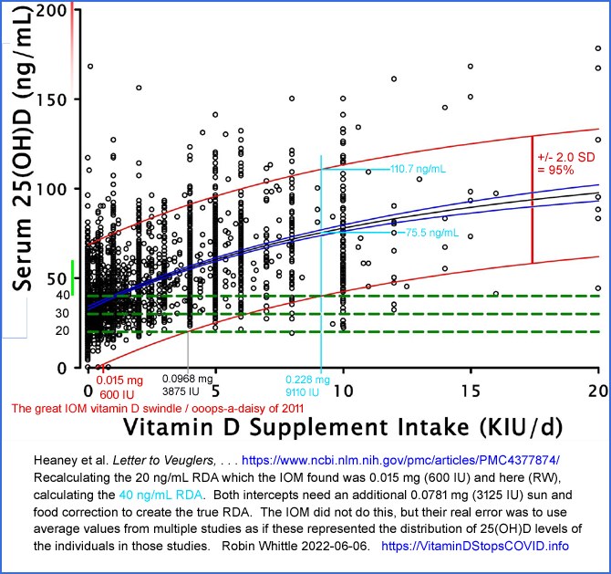
This depicts:
- The IOM's faulty 600 IU RDA (for 20 ng/mL).
- Heaney et al.'s 3875 IU value, also calculated for 20 ng/mL. To arrive at their estimated RDA, it is necessary to add an additional 3125 IU to account for the sun exposure and vitamin D3 consumed in food by their subjects.
- My estimated intercept for 40 ng/mL 100 nmol/L, at 9110 IU. Adding the 3125 IU correction to this results in an estimated RDA, for 40 ng/mL, of 0.306 mg 12,235 IU.
Despite the excellent work of Heaney et al. 2015, the veracity of which is not in dispute, the IOM has never been corrected and I am not aware of any government altering its IOM-based advice to account for the very low RDA they estimated in their egregiously faulty statistical analysis.
We can see from this that any attempt to ensure that 97.5% of a population of people have at least some healthy level of 25(OH)D, without any regard to their body weight or obesity status, leads to unnecessarily high intakes which for people with small bodies and no obesity, may be excessive.

Here is an account of knowledgeable researchers calling for a 25(OH)D standard of vitamin D repletion of ca. 125 nmol/L 50 ng/mL:
Cannell et al. 2006 proposed that 50 ng/mL (125 nmol/L) be the target 25-hydroxyvitamin D level, all year round:
Epidemic influenza and vitamin D
J. J. Cannell, R. Vieth, J. C. Umhau, M. F. Holick, W. B. Grant, S, Madronich, C. F. Garland and E Giovannucci
Epidemiology & Infection 2006-09-07
https://www.cambridge.org/...
The target range of 40 to 60 ng/mL (100 to 150 nmol/L) was stated in 2008 by 48 leading researchers and MDs in the Call to D*Action:
https://www.grassrootshealth.net/project/our-scientists/
This approximately 50 ng/mL level was fully justified by the research of Quraishi et al. 2014, mentioned at the start of this submission.
This 2020 review article, co-authored by the world's leading vitamin D researcher - Prof. Michael Holick - also calls for 40 to 60 ng/mL 25-hydroxyvitamin D:
Immunologic Effects of Vitamin D on Human Health and Disease
Nipith Charoenngam, Michael F. Holick 2020-07-15
Nutrients 2020, 12(7), 2097
https://doi.org/10.3390/nu12072097
40 to 60 ng/mL (100 to 150 nmol/L) was also suggested as the proper target range in this 2019 article (68 citations):
Daily oral dosing of vitamin D3 using 5000 TO 50,000 international units a day in long-term hospitalized patients: Insights from a seven year experience
Patrick J. McCullough, Douglas S Lehrer, Jeffrey Amend
Journal of Steroid Biochemistry and Molecular Biology V189, May 2019
https://www.sciencedirect.com/science/article/abs/pii/S0960076018306228 (Paywalled.)
https://sci-hub.se/10.1016/j.jsbmb.2018.12.010
This article also discusses the benefits some people find from much higher 25(OH)D levels, for suppressing inflammatory disorders such as psoriasis and rheumatoid arthritis. Please see https://vitamindstopscovid.info/06-adv/ for more on this and how it relates to our lack of helminths (intestinal worms).
Here is another recent research article:
Editorial – Vitamin D status: a key modulator of innate immunity and natural defense from acute viral respiratory infections
A. Fabbri, M. Infante, C. Ricordi
Eur Rev Med Pharmacol Sci 2020; 24 (7): 4048-4052 2020-04-05
https://www.europeanreview.org/article/20876
They mention that 40 to 60 ng/mL circulating 25OHD is required for the autocrine signaling system of immune cells to function properly. The proper term for this is intracrine signaling. See https://vitamindstopscovid.info/02-intracrine/#03-minlev for further discussion of this article.
16 years after the excellent work of Cannell and his highly experienced colleagues, we still have the UK and many other governments telling their people, and their doctors, that 50 nmol/L 20 ng/mL is sufficient for good health - and that 0.01 mg 400 IU vitamin D3 a day will provide them with the vitamin D they need to be healthy.
Likewise, 14 years after the 48 leading vitamin D researchers from multiple countries stated the same thing in the Grassroots Health Call for D*Action.
People pay their taxes, trust their governments, trust their doctors and (except for a few autodidacts) utterly depend on the advice of all these professionals to ensure their good health. Yet, in general, governments and most doctors, do the bidding of multinational pharmaceutical companies rather than assiduously pursue the truth about vitamin D and other nutrients, which would greatly improve the health of their populations and patients, in ways which are genuinely safe and effective, but not so profitable for the big corporations.

#05-history

6 - Vitamin D3 supplemental intake quantities as a ratio of bodyweight
While it is obvious that nutrient intakes should be proportional to bodyweight in order to attain any desired level within the body, and while it is very well known that bodyweight variation accounts for a lot of the scatter in dose-response data across multiple individuals, it would be unfair to blame doctors, advisors and governments for not adopting bodyweight ratio based vitamin D supplemental intakes.
It is routine to specify many drug quantities as ratios of bodyweight, so the concept is fundamental to medicine. However, there has been a paucity of research into vitamin D3 supplemental intakes specified as a ratio of bodyweight.
If it were acceptable to have doctors and other healthcare professionals fussing over everyone's 25(OH)D levels on a continual basis, then no such ratio-based guidance would be needed. Each person would adjust their supplemental quantities until their 25(OH)D blood tests returned values they or their doctor decided were acceptable.
However, this does not work for babies - or for almost anyone else. The cost and inconvenience of blood tests is totally excessive, and vastly more expensive than the minimal cost of weekly (to every 10 days) vitamin D supplement capsules or tablets. (In the USA, I have been reliably informed, hospitals charge insurers USD$300 per vitamin D test.) Even if vitamin D tests were non-invasive and free, this level of medical involvement is excessive.
The question is how to devise guidance, which any literate and minimally numerate person can follow, to ensure that most people (ideally everyone, but this is impossible - 90 to 95% would be good) supplement enough vitamin D3 at all stages of their life, to maximise their health.
There is a wide range of 25(OH)D levels which will ensure this, except for those with autoimmune inflammatory disorders who generally need more than 125 nmol/L 50 ng/mL 25(OH)D to suppress these symptoms, in the absence of helminths.
The situation is made much easier by the very wide gap between the minimal level, as just mentioned, and the level three times this - 375 nmol/L 150 ng/mL at which toxicity may become a problem for some people.
The situation is made easier still by the strong self-limiting nature of the activity of the 24-hydroxylase enzymes which degrade 25(OH)D in proportion to its level.
So despite widespread, ill-informed, fears of toxicity, vitamin D is a relatively easy nutrient to choose intake quantities for, without any medical involvement. This can only be done by basing it on ratios of bodyweight, with different ratios for those suffering from obesity.
The guidance below was validated and in part developed by Prof. Sunil Wimalawansa. It has been adopted by the Front Line COVID-19 Critical Care Alliance (FLCCC) in their IMASK+ COVID-19 early treatment protocol (as a general measure for health, not as treatment for any disease):
https://covid19criticalcare.com/covid-19-protocols/i-mask-plus-protocol/
The FLCCC is a consortium of doctors in the USA, Italy and Brazil who lead the world in the treatment of COVID-19. Their recommendations are relied upon by thousands of other healthcare professionals.
Ideally there would have been multiple trials of ratio-based vitamin D supplemental intake quantity protocols. ("Supplemental intake" is appropriate. This is nutrition. "Dose" is appropriate for medicine.)
Only one such research study has been published. Iranian MDs at a hospital in Dubai, UAE have been using ratio-based vitamin D3 supplemental quantities since 2010 with some opthalmology patients, and, with great success since early June 2020 with all their COVID-19 patients.
Suggested role of Vitamin D supplementation in COVID-19 severity
The authors are directors at Iranian Hospital Dubai, Dubai, UAE: Parviz Afshar Hospital Director, Mohammad Ghaffaripour ICU Director and Hamid Sajjadi Neuro-Ophthalmology Director
Journal of Contemporary Medical Sciences Vol 6 No 4 (2020): July-August 2020 2020-08-26
http://www.jocms.org/index.php/jcms/article/view/822
This short article is packed with interesting items. Highlights include:
- 500+ neuro-opthalmology patients. Unsupplemented, 95% had 25(OH)D levels below 87.5 nmol/L 35 ng/ml.
- Ratio-based vitamin D3 supplemental intake quantities of 70 to 100 IU D3/day per kg bodyweight.
- Supplemented on this basis since 2010 all attained at least 100 nmol/L 40 ng/mL with none over 225 nmol/L 90 ng/mL. Unsurprisingly, this involved no toxicity. (However, I have been reliably informed by an Australian MD that she would expect some people to exceed this upper 25(OH)D level with these intakes.)
- 21 patients (including 2 healthcare workers and several with chronic disease) who had > 100 nmol/L 40 ng/mL 25(OH)D and who had COVID reported maximum stays in hospital under 4 days.
- In early June 2020 they started supplementing all COVID-19 inpatients with 7.5mg 300,000 IU intramuscularly plus (presumably oral) D3 at 100 IU/day/kg == 0.0025mg/day/kg. For a 70kg person this is 0.175mg 7000 IU/day. This is in addition to hydroxychloroquine, Remdesivir and other treatments. This resulted in:
. . . a dramatic and complete resolution of ICU admissions was observed in the last 8 weeks.
We cannot over-emphasize the role of Vitamin D in controlling all infectious diseases especially in COVID-19. We had no patients with initial Vitamin D levels of > 100 nmol/L 40ng/mL that required more than 2 to 3 days of hospitalization, hence no cytokine storm, hypercoagulation, nor complement deregulation occurred.
Prior to this change, we had several deaths of COVID-19 patients on respirators.
They recommend 70 to 100 IU/day/kg ratio-based D3 supplemental intake for all people, with a potential simplification for people between 50kg and 100kg: to a 1.25mg 50,000 IU capsule per week, which is 0.178mg 7143 IU / day. (143 to 71 IU/day/kg.)
For people with < 75 nmol/L 30 ng/mL 25(OH)D, they recommend 7.5mg 300,000 IU D3 intramuscular injection, followed by bodyweight ratio-based daily intakes. However, without the initial injection, such people would still reach the desired range of 25(OH)D levels after several months. A bolus D3 starting dose would achieve the same goal of earlier repletion, which would be especially valuable in an environment of threatening infectious disease.
For people with 75 to 100 nmol/L 30 to 40 ng/mL they recommend just the ratio-based intakes. For people with > 112 nmol/L 45 ng/mL they suggest retesting after a few days to check for a possibly erroneous initial reading, and then testing every 4 months after that. Below, by "normal" they mean "healthy".
. . . we would like to propose changing the VDL to 40 to 100 ng/mL as normal and consider below 40ng/ml as deficient.
Restating this in nanomoles per litre:
. . . we would like to propose changing the VDL to 100 to 250 nmol/L as normal and consider below 100 nmol/L as deficient.
Sidebar on the journal and Iranian research:
The Journal of Contemporary Medical Sciences (about) was launched in 2015 and is a quarterly peer-reviewed open access publication of Nab’a Al-Hayat Foundation for Medical Sciences and Health Care, Iraq.
I am wary of journals I have never heard from non-Western countries, but this is legitimate, being listed in Index Copernicus and not mentioned in this list of predatory journals: http://olddrji.lbp.world/administrator/RejectedJournals.aspx . The not for profit hospital is the oldest in Dubai http://www.ihd.ae/about-us and is primarily staffed by Iranians. https://en.wikipedia.org/wiki/Iranian_Hospital,_Dubai .
This is the latest in a long line of excellent nutrition research I have read from Iran and/or Iranians.
This is a good basis on which to regard:
70 to 100 IU D3/day per kg bodyweight
as a good range of ratios for a global, all ages, all bodyweights, vitamin D3 supplemental intake protocol, without the need for testing or medical supervision, except as required due to possible or actual ill-health.
Here is some terminology for the range of ratios:
70 IU / day per kg bodyweight is the base ratio.
100 IU / day per kg bodyweight is the upper ratio.
Devising such a protocol as this and having it adopted by most people, worldwide, would end what is often referred to as the "vitamin D deficiency pandemic" and bring enormous health and happiness benefits.
This simple range of ratios can be improved upon by devising a correction factor to account for the widely and uncontroversially recognised problem faced by people suffering from obesity: that their 25(OH)D levels are significantly lower than those which would result from the same vitamin D3 intake as ratios of bodyweight for people who were not suffering from obesity.
The problem seems to be obesity, not being simply overweight.
Definitions of overweight, obesity and morbid obesity are problematic, since the BMI formula has long been known to overestimate obesity in tall people, and so underestimate it in short people, including babies, children and adolescents. In this discussion we have no precise definition of obesity and morbid obesity. Waist vs. height and clinical assessment may be more appropriate than BMI for determining this. Obesity is a serious over-inflammatory metabolic disorder which warrants medical attention. In such circumstances doctors may well make specific nutritional decisions. The purpose of the bodyweight ratio-based vitamin D protocol is to provide general guidance, in the absence of medical advice to the contrary.
The best research article on which to base judgments about an "obesity correction factor" is:
The Importance of Body Weight for the Dose Response Relationship of Oral Vitamin D Supplementation and Serum 25-Hydroxyvitamin D in Healthy Volunteers
John Paul Ekwaru, Jennifer D. Zwicker, Michael F. Holick, Edward Giovannucci and Paul J. Veugelers. PLoS One 2014-11-05
https://journals.plos.org/plosone/article?id=10.1371/journal.pone.0111265
Here is an annotated version of their Figure 3, from the PDF version of the article, which for some reason does not appear in the HTML version.
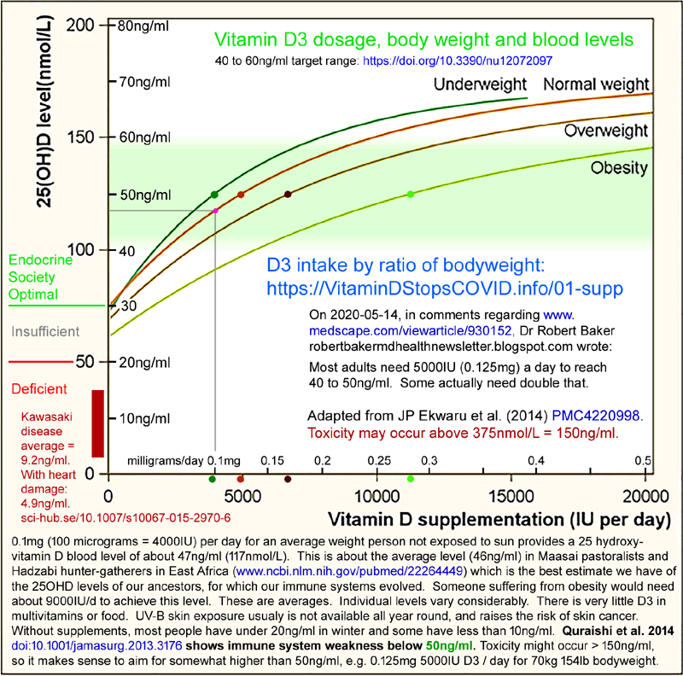
These four curves are averages from 22,214 25(OH)D readings of 17,614 healthy North American adults participating in a preventive health program. So this is a self-selected sample of the population. "Underweight" "normal weight", "overweight" and "obesity" are therefore self-described items of data, rather than being based on clinical judgments made in a consistent framework.
We assume a normal bodyweight of 70kg (154lb), while recognising that normal bodyweights (not average - normal, healthy, non-overweight, non-obese) bodyweights for Asians are somewhat less than this.
For 70 kg bodyweight, 5000 IU / day is close enough to 70 IU/day/kg. We see that this results in average 25(OH)D levels of 125 nmol/L 50 ng/mL.
The self-limiting mechanisms which control 24-hydroxylation of 25(OH)D are evident in all four curves flattening out at higher 25(OH)D levels. This means that the upper ratio, 100 IU/day/kg, which is 1.43 times the base ratio, will not result in mean 25(OH)D levels of 1.43 times 125 nmol/L 50 ng/mL. Indeed, the intercept from 7000 IU with the "Normal weight" curve gives a level of about 145 nmol/L 58 ng/mL. This leveling off of the slope of these curves would be called "compression" in electronics. It makes our task much easier than if 25(OH)D levels rose linearly in proportion to vitamin D intakes.
Our task now is to determine what, if any, correction factor to apply to the initial range of ratios to make them more suitable for people who are overweight, or suffering from (self-described) obesity, in a context where there was no separate option to report "morbid obesity".
This requires some judgments about to what extent, at 125 nmol/L 50 ng/mL, the D3 intakes for the "Overweight" and "Obesity" curves indicate that the extra D3 requirement to attain this level is out of proportion to the extra weight, for adults. This is tricky given the lack of formal definitions and the self-described nature of these data.
#ek-2.5-and-2-to3
Fortunately, Ekwaru et al. have quantified this:
We recommend vitamin D supplementation be 2 to 3 times higher for obese subjects and 1.5 times higher for overweight subjects relative to normal weight subjects.
It is a common error of expression to use "times higher" rather than "times the (whatever the reference item is)". So we interpret these statements as meaning:
Overweight people should supplement 1.5 times the amount of vitamin D3 normal weight people need.
People suffering from obesity should supplement 2 to 3 times the amount of vitamin D3 normal weight people need.
They mention "two to three times more" in their abstract, citing the Endocrine Society, and note that their article is intended to provide a research basis to justify this, which the Society acknowledged was lacking. They are referring to the Endocrine Society's guidelines:
Evaluation, Treatment, and Prevention of Vitamin D Deficiency: an Endocrine Society Clinical Practice Guideline
Michael F. Holick, Neil C. Binkley, Heike A. Bischoff-Ferrari, Catherine M. Gordon, David A. Hanley, Robert P. Heaney, M. Hassan Murad and Connie M. Weaver
Journal of Clinical Endocrinology & Metabolism 2011-07-01
https://academic.oup.com/jcem/article/96/7/1911/2833671

This article recommends the IOM's mistaken 600 IU RDA for all but those with obesity and those on particular medications. Holick et al.'s terminology regarding higher intakes for those with obesity involves similarly awkward and imprecise expression:
(2.5) We suggest that obese children and adults and children and adults on anticonvulsant medications, glucocorticoids, antifungals such as ketoconazole, and medications for AIDS be given at least two to three times more vitamin D for their age group . . .
[Normal weight] . . . maintenance therapy of 1500 – 2000 IU/d.
From their page 1924 restatement of rec. 3.5:
3.5 In obese patients, patients with malabsorption syndromes, and patients on medications affecting vitamin D metabolism, we suggest a higher dose (two to three times higher; at least 6000 –10,000 IU/d) of vitamin D to treat vitamin D deficiency to maintain a 25(OH)D level above 30 ng/ml, followed by maintenance therapy of at least 3000 – 6000 IU/d.
They clearly mean "2 times" to "3 times" the:
[Normal weight] . . . maintenance therapy of 1500 – 2000 IU/d.
Table 3 shows in the right two columns the Endocrine Society recommendations alongside the sliced and diced arrangement of the IOM in the middle. For adults 19 years and above, the Endocrine Society daily requirement is 1500 to 2000 IU/d, with 10,000 IU being the Endocrine Society "upper level", with nothing about obesity, since this is not an element of the Endocrine Society's recommendations.
"Average weight" means a BMI of 18.5 to 20 - so I assume an average BMI of 19.25.
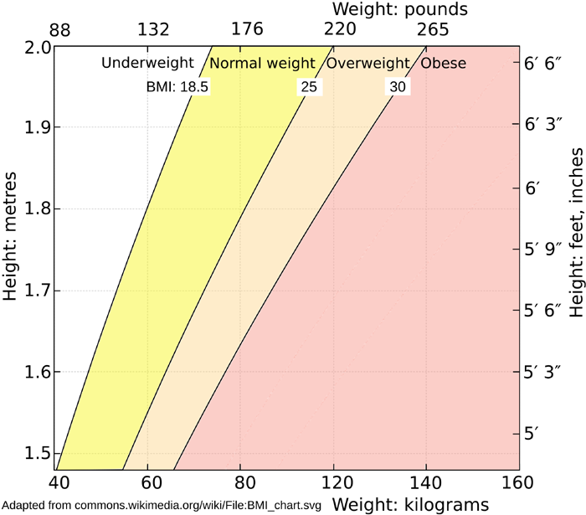
The average BMI of overweight people is 25 to 30 = an average of 27.5, which is 19.25 x 1.425 . So on this basis, we don't need a ratio different from the normal weight range of ratios, 70 to 100 IU/day/kg, for overweight people to achieve their goal of 1.5 times the D3 intake of average weight (non-overweight) people. (This 1.5 is from our above reinterpretation of the statement by Ekwaru et al. #ek-2.5-and-2-to3.)

Obesity is open ended: BMI > 30. (The above chart has no category for "morbid obesity".) If we take the mid-point of another step of 5 upwards, this is 32.5 as the low end of obesity = 19.25 x 1.69. To match this with a low end target of 2 times the average weight D3 intake (where 2 is from the above re-interpretation of the statement by Ekwaru et al. #ek-2.5-and-2-to3), we need a ratio (2.0 / 1.69) = 1.1834 x the amount of vitamin D3 ordinary weight people take.
If we assume that the average high end of obesity is another 5 above this: 37.5 = 19.25 * 1.948. Ekwaru et al. suggest (in our reinterpretation, above, of their statement) that people suffering from obesity need 3 times the average weight D3 intake, so we need a ratio (3.0 / 1.948) = 1.54 x the amount of vitamin D3 ordinary weight people take.
Since there is such a high safety margin, since some people may benefit from higher intakes and since aiming for 50ng/ml means half the people will have less than this, we can adopt approximately 1.50 as the correction factor for obesity, to be applied to the initial Afshar et al. ratios above:
For people suffering from obesity:
70 x 1.43 = 100 IU / day per kg bodyweight is the base ratio.
100 x 1.5 = 150 IU / day per kg bodyweight is the upper ratio.
Since the original data had no option for morbid obesity, and since people suffering from this may not have been well represented in the dataset, Prof. Wimalawansa chose to make another range of ratios approximately 2.0 times that of the ratios for normal weight people, to suit those with the open ended, but clinically perilous, diagnosis of morbid obesity:
70 x 2.14 = 150 IU / day per kg bodyweight is the base ratio.
100 x 2.0 = 200 IU / day per kg bodyweight is the upper ratio.
This is tabulated, in the FLCCC IMASK+ protocol https://covid19criticalcare.com/covid-19-protocols/i-mask-plus-protocol/:
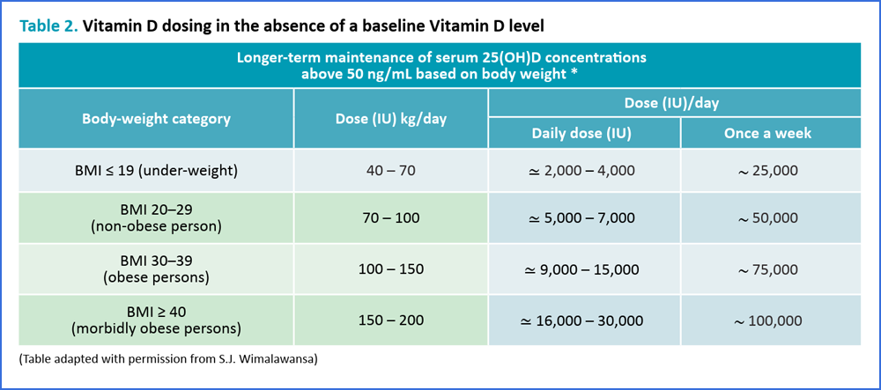
The lower set of ratios for underweight people may be an extrapolation based on the assumption that with less adipose tissue, their 25(OH)D levels will be easier to raise. However, I know of no experimental evidence or statements by other researchers to support this.

Update history
2022-05-15: Version sent to the OHIC.

2022-06-06: Thanks to notes and suggestions from Robert Lutey, corrected numerous typos and expression errors. No new material has been added. Most typos were insignificant, but the following corrections were for potentially significant errors in the text sent to the OHIC. (Page numbers are for the Word and PDF files sent to the OHIC before deadline.)

- Page 5 para 1 line 2: “1.75 mg” should have been “0.175 mg”.
- Page 2 Graph: Risk of infection with 62.5 nmol/L 25 ng/mL 25(OH)D “26%” should have been “18%”.
- Page 14 para 5 “1/1800” should have been “1/800”.
- Page 62 para 3 “100 IU/day/kg” should have been “70 IU/day/kg”.
- Page 64 para 3: The last three instances of “IOM” should have been “Endocrine Society”.

As with the Word and PDF files submitted before deadline, the font used is Times Roman, whereas the website version:

https://vitamindstopscovid.info/00-evi/
and the PDF copy of this uses a sans serif font (Roboto) which is generally easier to read. The corrected version you are now reading has somewhat improved formatting, however, the formatting of the website version and its PDF copy at https://vitamindstopscovid.info/00-evi/#pdf is much better, with more links within the document.
You may prefer to read the website version, which has the same text as above, plus:

- A section arguing against food fortification, which I could only complete after deadline.
- Likewise a section on how the UK government currently misinforms the public about vitamin D in a way which causes a great deal of harm and death.
- Likewise a section on how governments can only serve their people by regaining and maintaining the public’s trust. This can only be achieved by taking the best advice from knowledgeable researchers and clinicians, ignoring the pressures from pharmaceutical companies and by allowing and encouraging full and free debate about all matters, including those concerning health.
- The website version contains the calcifediol patent graph which shows how quickly (4 hours) 25(OH)D levels can be raised with a single oral dose of calcifediol, which is 25(OH)D.
© 2022 Robin Whittle Daylesford, Victoria, Australia Please reproduce sections with full attribution to https://vitamindstopscovid/00-evi/ . Do not copy the entire document anywhere - refer to this site, since there will no-doubt be corrections and other improvements.

